Go off-grid – Try Orienteering Social media posts
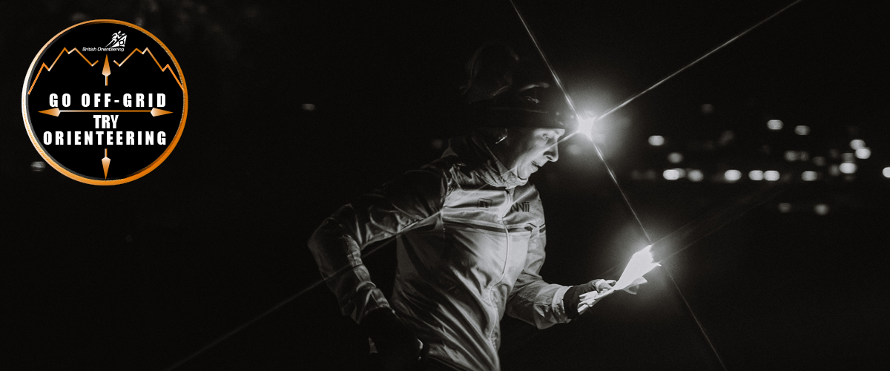
Inspired by challenge and pace? Fuelled by the desire to go off-grid on your trails and unleash that unmatched energy – orienteering is for you! 🗺️ 🏃 ⛰️
Experience running routes like you never have before. Discover why you should get started with us today: [press release]
#offgrid #tryorienteering #orienteer #orienteering #britishorienteering #adventuresport #ditchthetrail #runningmotivation #running
________________________________________________________________________________
Orienteering turns the usual on its head.
You do not know where your trails will take you until you get your map at the start, showing the checkpoints you need to visit. From that moment on, every decision is yours.
Which route will you take? How hard will you push? It’s time for to you to decide.
Learn more at: [press release]
#offgrid #adventuresport #doitforthethrill #orienteering #britishorienteering #bucketlistsport
________________________________________________________________________________
Getting started in orienteering is simple.
You do not need to be a club member or have any prior experience to take part. Most events are open to everyone, with beginner-friendly courses and support available on the day.
Mix it up and move away from the same old paths and trails, and open up a Pandora's box worth of route possibilities!
#orienteering #tryorienteering #goorienteering #orienteeringclubs #orienteeringevents #running #offtrail #adventuresport
[press release]

_______________________________________________________________________
Already running trails? Join ours!
Less predictability, challenges that feel rewarding and most importantly, off-grid in places you may have been to, but not like this!
Your aim is simple: get to all the checkpoints on a special orienteering map in the fastest time.
Ready to step up? Go off-grid – Try Orienteering today.
[press release]
______________________________________________________________________
Looking for something that will challenge your endurance further?
This is off-grid. This is orienteering.
Your resilience will be tested, sometimes amongst the most technical of terrains, but the thrill is in finishing in the quickest time possible. Every second counts.
Want to learn more? Get started here: [press release]
__________________________________________________________________________
New adventure sport on the bucket list for 2026?
How about something that combines mental resilience as well as speed?
You’ve found what you have been looking for – go off-grid with us and try orienteering.
Unleash your unmatched energy today: [press release]
_____________________________________________________________________________

