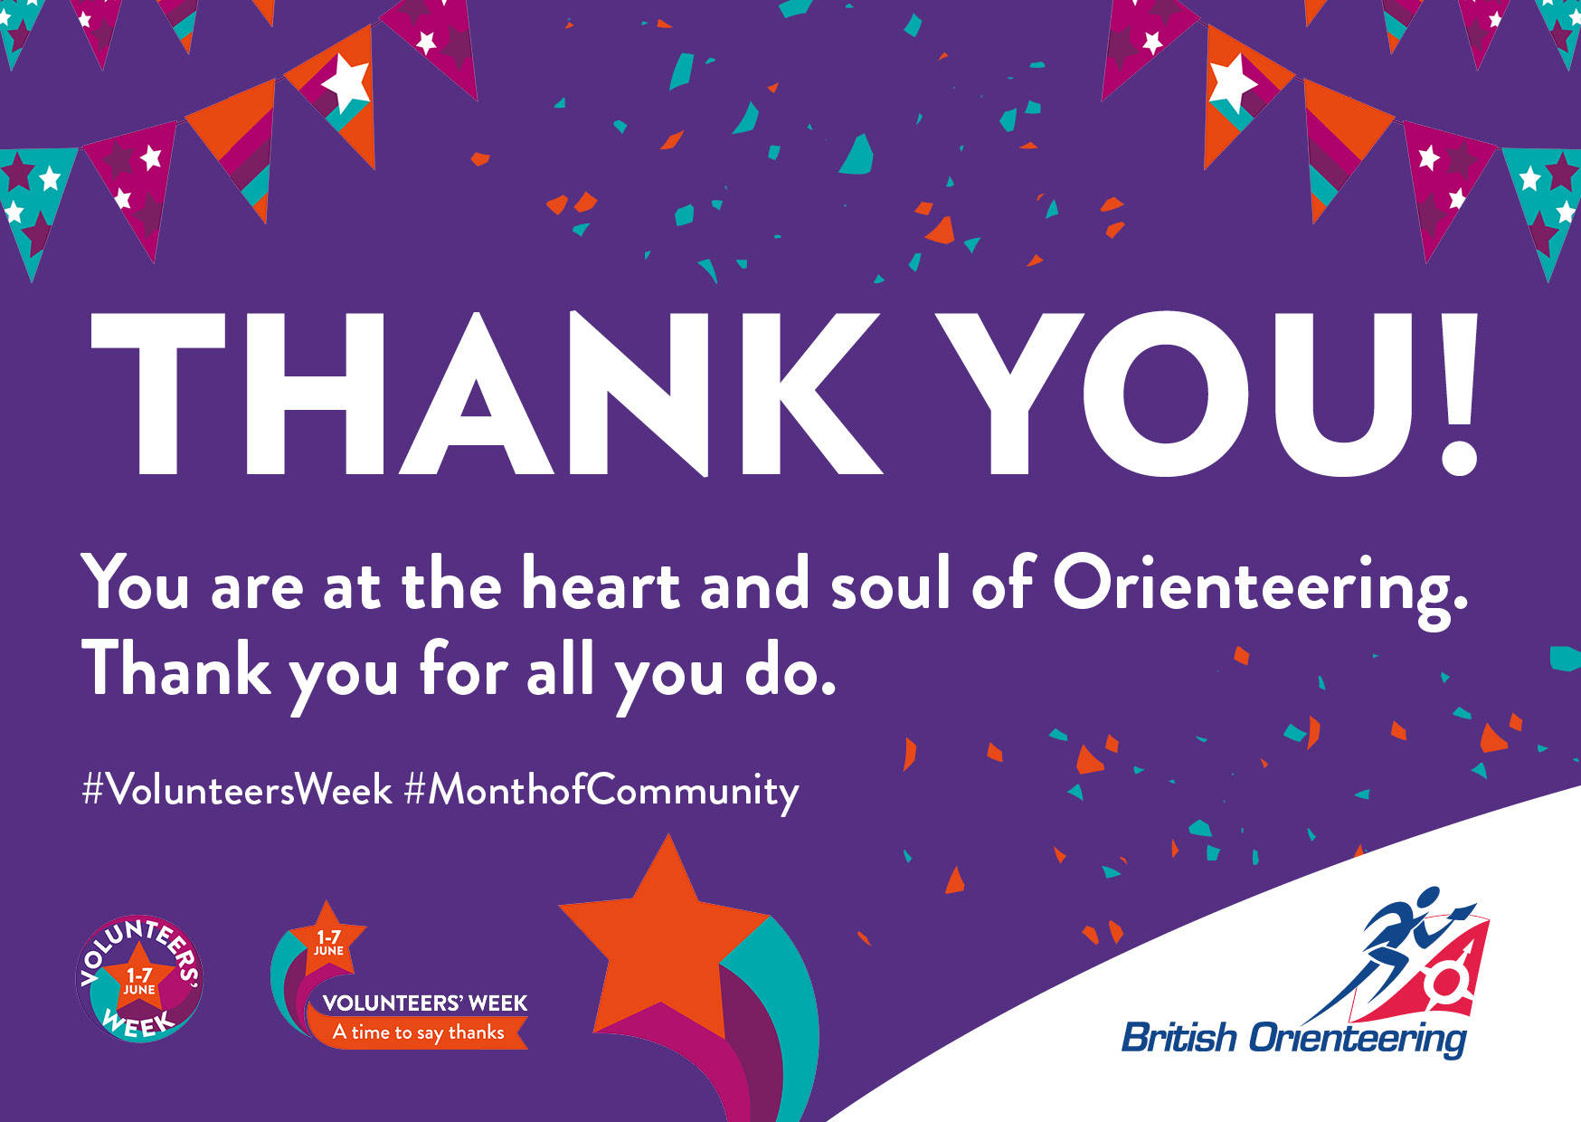
Ergffer;lee;lre;ljverkler
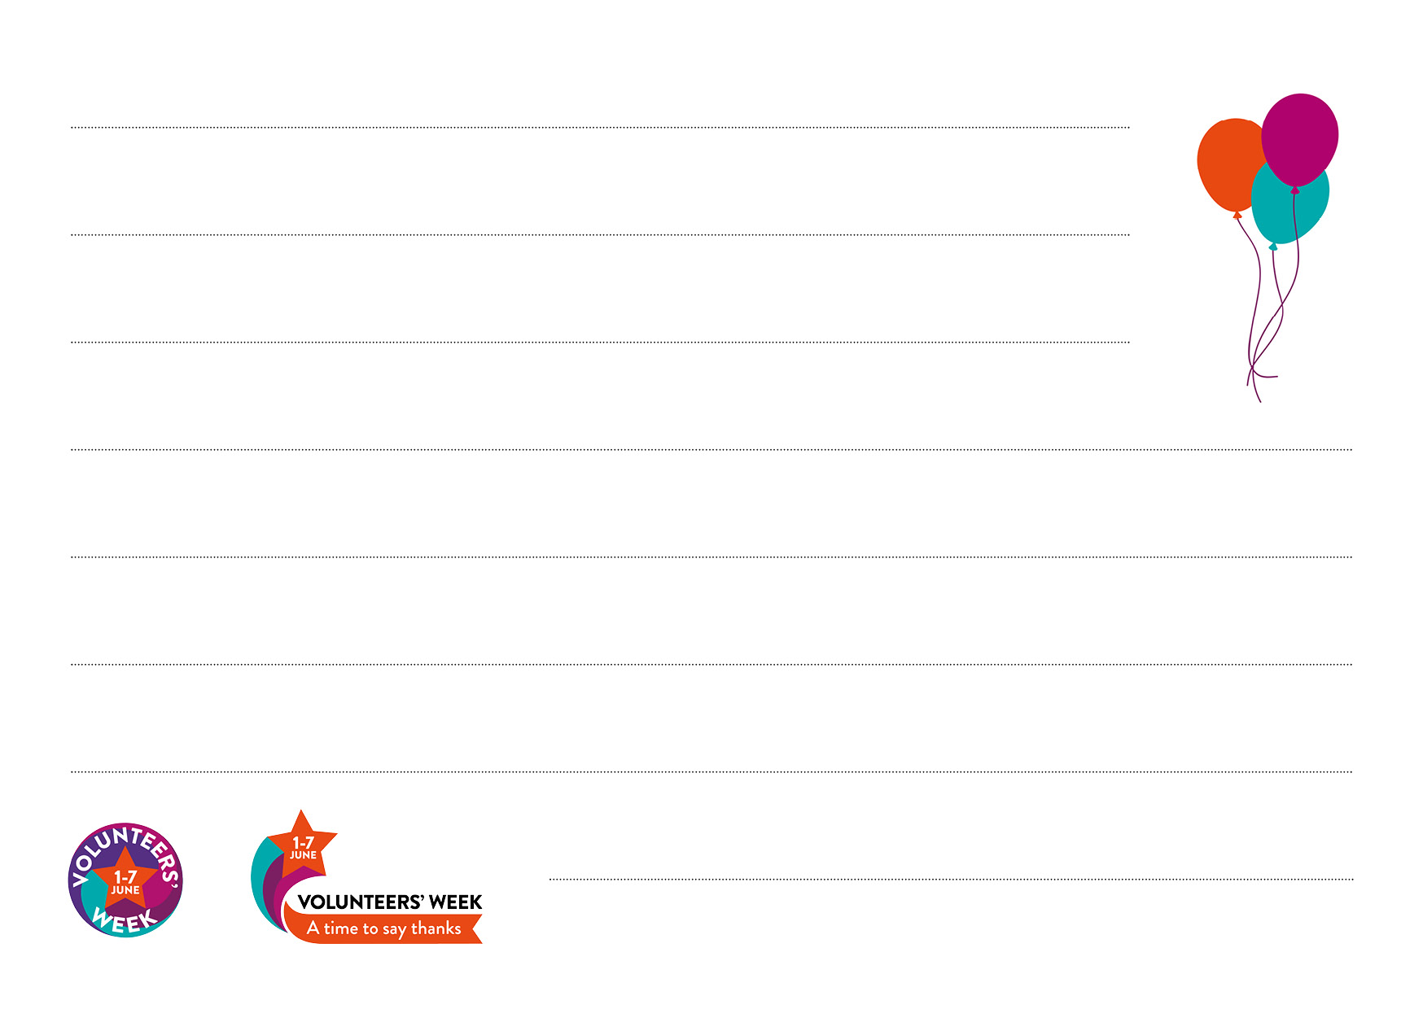
Dear xxxx,
Thank you for everything you have done this year.
All the very best.
British Orienteering team.

