Checking Control Site Locations with GPS

Introduction
Every orienteering event aims to ensure that all controls are placed where competitors expect to find them according to their map. Unfortunately, and for various reasons, this does not always happen.
This document aims to help you accurately map, place or check control sites using a suitable GPS-enabled device, particularly those that can display a georeferenced (orienteering) map. Descriptions are provided to help you improve accuracy and produce suitable files of competition maps to aid control placement and checking with hand-held devices.

Coping with GPS displacement
GPS capabilities vary with devices, atmospheric conditions and the local environment. A GPS “fix” at the same location may also vary with time. Most mobile phones and consumer GPS units quote accuracies of about 3m – 10m, though some professional systems claim sub-centimetre accuracy. Mobile phones and consumer GPS units should be quite adequate for orienteering purposes when used with a georeferenced map that has been drawn with the aid of Lidar and other georeferenced base materials and tools.
The process described here can be adapted for use with any GPS-enabled device that can show your position on an orienteering map. This includes the Android version of Open Orienteering Mapper, OCAD Sketch, some Garmin GPS devices and other mobile applications such as Avenza maps.
This process focuses on using GPS to show the location of a control site relative to the GPS locations of other known and mapped features. The GPS device is a tool to help with control placement. Competitors will only have a map, so it is important that controls are placed accurately relative to nearby features on the map.
On the right-hand side of the diagram below are three waypoint “fixes”, shown as blue dots, plotted on a mobile phone at the locations of a depression and two path junctions. The offset between the mapped depression and its GPS “fix” (the top blue dot) is about 10m. In the context of checking control sites, you can improve this accuracy.
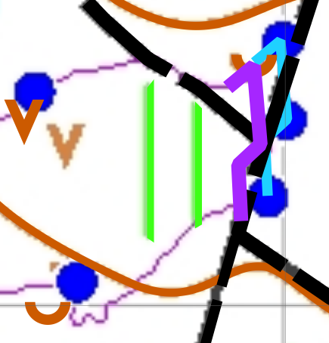
The blue line connects the mapped depression and the three blue dots. The magenta line is an exact copy of the blue line but has been moved to align the two path-junction “fixes” to the path junctions they represent. This shows that the depression has been adequately mapped relative to the path junctions within a meter or so. This should be sufficient to easily differentiate confusable control sites. If not, perhaps it would be better to consider using a more a distinctive and unambiguous control site.
You can adopt this approach when checking control sites by visually estimating the relative positions of known features to the feature of interest. The waypoint “fixes” for the pit and depression on the left-hand side of the map were taken at the same time and similar offsets apply.

Producing maps for control siting and checking
This section gives examples to help produce all-controls maps for use with Open Orienteering Mapper (OOM), and Avenza Maps using OOM and Condes and Purple Pen planning software. These processes should be adaptable for use with other systems such as Garmin GPS devices. OCAD Sketch should be straight-forward to use if also used for course planning.

OOM
Start by getting the georeferencing information of the competition map ready to apply to the file exported from Condes.
Open the competition map in OOM.
From the main menu select Map | Georeferencing to open the dialog.
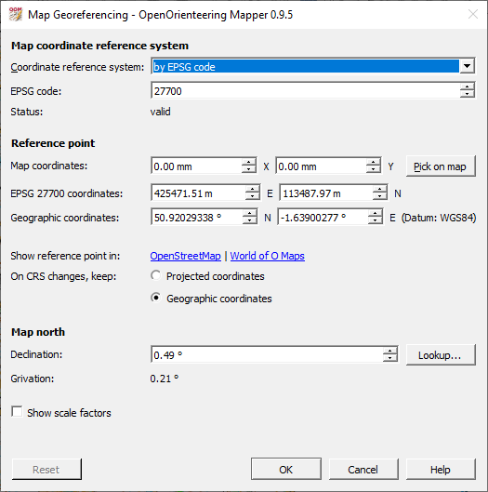

Creating a file of control data
The control data is created with your planning software. Details are given for Condes and Purple Pen.

Condes for Avenza Maps (georeferenced pdf files)
Although it may not be immediately obvious, a pdf file exported from Condes may be geo-referenced if the canvas map used for course planning is geo-referenced.
From the Condes main menu, select Export | Export maps and courses as PDF…
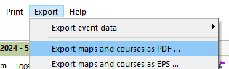
A dialog opens. Under Select which courses to export ensure only All Controls is selected. Include map should be ticked and for PDF file you should select All courses in one PDF file. When your selection is complete, click on the Export button.
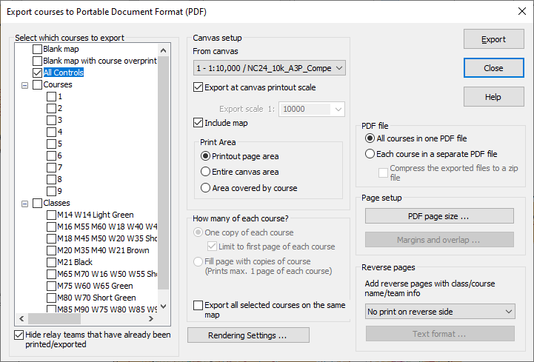
A Save As dialog will open to allow you to save the pdf file containing the map and controls with a name and to a location of your choice.
You may want to save or copy the pdf file to the Download folder of your device. You can then open it within Avenza Maps.

Condes for Android OOM files
Open the event file in Condes.
If there is a blue “print area frame” around the map, it can be removed toggling the Draw frame around print area option from the main menu or by clicking the icon on the main toolbar.
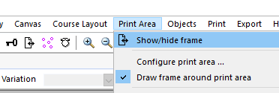
From the main menu select Export | Export courses to OCAD…
A dialog opens.
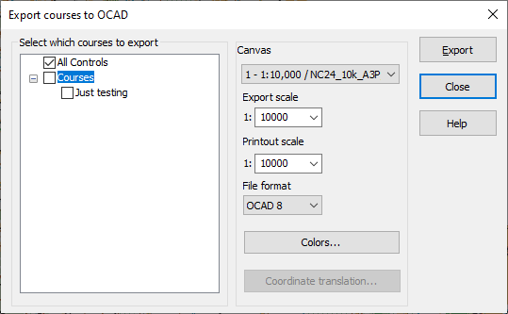
Select only All controls before clicking on the Export button.
Provide a suitable name for the file such as <Event name> All Controls.ocd and save the file in OCAD 8 format.

Georeference the all-controls file
This is only required with Condes versions that create files in OCAD formats that do not support geo-referenced map files e.g., OCAD 8.
Open the exported all controls file in OOM. Ignore any map import warnings.
From the OOM main menu select Map | Georeferencing. The Georeferencing dialog will open.
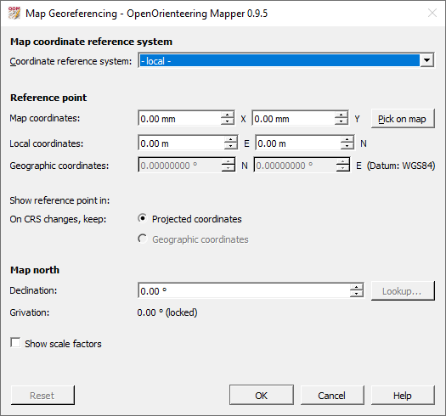
Update the details in the Map Georeferencing dialog so that it corresponds to the settings for the competition map.
Change the Coordinate reference system to “by EPSG code”.
Set the EPSG code to 27700. This corresponds to the Ordnance Survey system.
Enter the Map coordinates and Local coordinates to match the values used for the competition map. The Geographic coordinates should update to match.
Check that the On CRS changes, keep: setting matches the competition map setting (should be Geographic coordinates).
Update Declination to match the competition map setting.
Click on OK. A dialog will probably appear warning that the Declination has been changed and inviting you to rotate the map. Click on the No button.
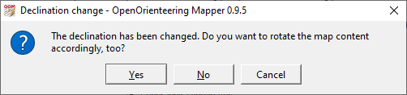

Select Save As to save the map file in *.omap format. By default, OOM will save the file in its original format. The file exported from Condes will be in OCAD 8 format, which does not support georeferencing.

Purple Pen
Open the event file in Purple Pen.
From the main menu select File | Create OCAD files…
A dialog opens.
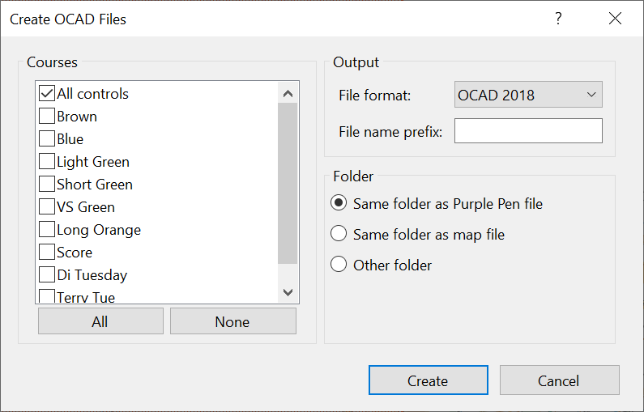
Select just All controls. The File Format can be OCAD 2018, OCAD 12 or earlier but the later versions will likely be better. When you are content with the settings, click the Create button.
You will be prompted to enter a file name. Check the file path and name then click on the Save button.

Create the all-controls competition map file
Open the competition map in OOM.
From the main menu select Map | Add new part… and give the new part a suitable name such as “AllControls”.
Import the All controls map you have created via File | Import. You may see a dialog appear inviting you to assign new symbols. Click on OK.
Your controls and control descriptions should appear over the competition map, correctly aligned.
Select File | Save As to save this file with a suitable file name such as <Event name> All Controls.omap. You can then copy it over to your Android device as an aid to placing and checking controls.

Loading KMZ Map Files into Garmin Handheld Devices
1) Download and install Garmin BaseCamp from this website:
https://www.garmin.com/en-GB/software/BaseCamp/
2) Connect your Garmin handheld GPS device, such as an eTrex using an appropriate USB cable to your computer.
3) Run Garmin BaseCamp, and select My Collection under Library in the side panel:
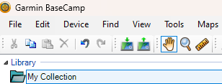
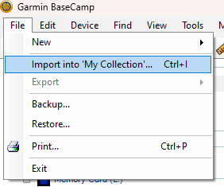
4) Select Import into ‘My Collection’... from the File menu:
Using the dialog box that appears, browse to the location of the KMZ map file and press Open
5) The selected map file will now appear in your Library as shown below:
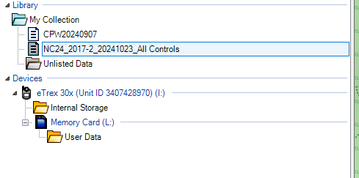
6) Double-clicking on the entry, the map will display it in the main map area of BaseCamp: 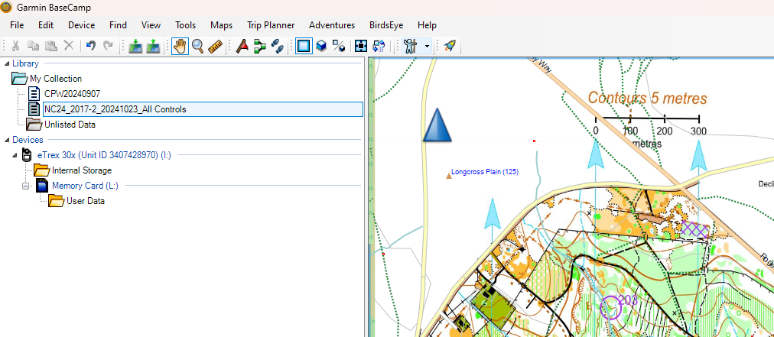
Note: if the imported map seems to be misaligned with background map detail, check that the settings for Grid and Datum under the options Measurement section are as shown below (Edit menu and then Options):
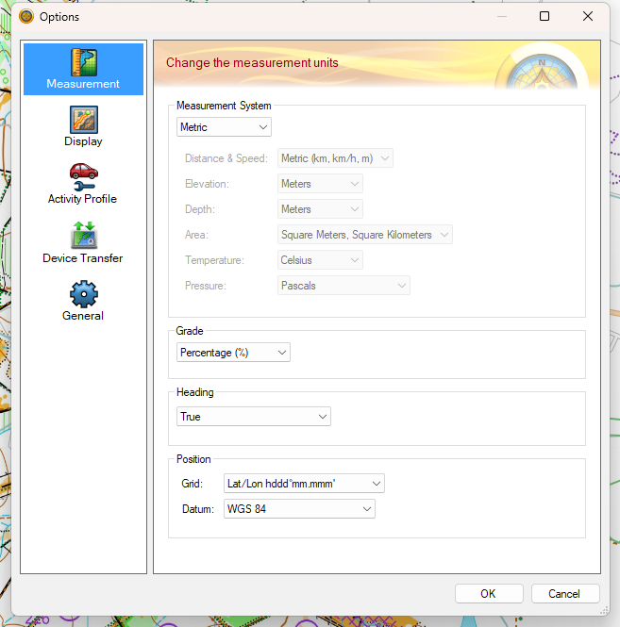

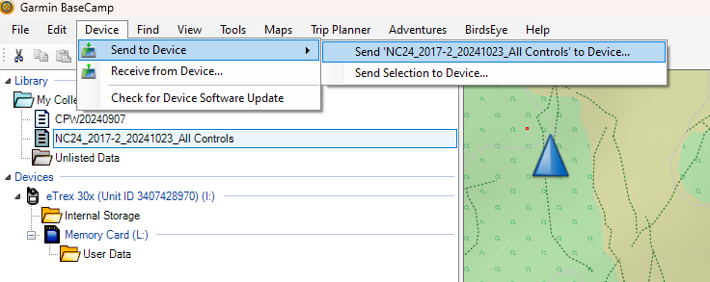
7) With that map file selected in the My Collection sidebar area, click on Send to Device and then Send ‘[map name]’ to Device… from the Device menu:
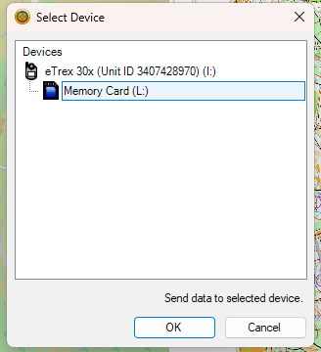
8) In the dialog box that appears, select the device you want to copy the map file to, and where appropriate whether it is inbuilt memory or expanded storage:
Press OK
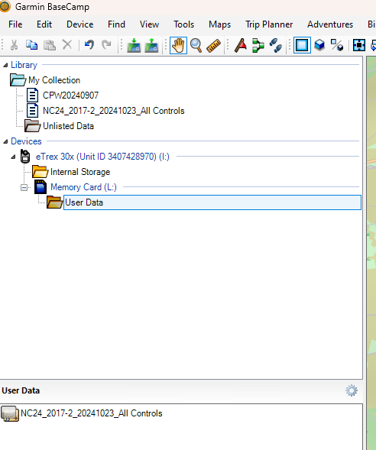
9) To check that the map file has copied successfully, click on the device in the BaseCamp sidebar, and the map should appear in the lower pane as below:
10) Close BaseCamp and disconnect the device – it will now display the loaded KMZ map when in the correct geographic area.
Note: if the map does not appear, check that Custom Maps are enabled on the device, by selecting Setup, Map, and Map Information.

OCAD Sketch
OCAD Sketch provides similar functionality to the Android version of Open Orienteering Mapper.
This link will take you to the OCAD Sketch app help.
https://www.ocad.com/wiki/ocad/en/index.php?title=OCAD_Sketch_App
You don’t need OCAD (2018) to use the Sketch App. Someone else with access to OCAD 2018 can export the data to the OCAD Cloud storage and send you a link to download the map.
If you have access to OCAD 2018 you have the option to export a map using OCAD Sketch App Data Exchange – this could just be the blank map or an all-controls map (if you use OCAD Course Setting or import an All Controls OCAD export from Condes (or Purple Pen). OCAD Sketch App on a phone or tablet will show your live location over the georeferenced map.

Exporting a KMZ file from OCAD
If using OCAD 10 or newer for your base map - you can export a KMZ Google Earth raster file (select the option for Garmin Custom Maps optimized).
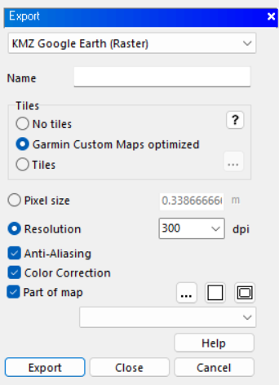

Garmin Handheld devices
A KMZ file can be saved to the Custom Maps folder on any Garmin Handheld (such as Oregon, Montana or GPS 66sr). The GPS 66sr uses multi-band GNSS (as do some phones such as a Google Pixel 7 or newer). Multi-band GNSS can give an accuracy of better than 1m in open areas and typically better than 3m in forested areas.
The KMZ map exported from OCAD can be either a blank map or one with control sites.

Garmin Watches
The latest Garmin watches such as the Forerunner 255 or 965 also have the option to use Multi-band GNSS although they cannot display your live position over an orienteering map. A track recorded with these watches can be used later (imported into OCAD) to show that you have correctly visited control sites. If using a Garmin smartwatch, ensure the watch is set to record a position every second rather than using SMART mode (Settings, System, Data Recoding, Frequency – Every Second).

MapRun
If using Condes for the course planning there is the option to export a “KML (Simple)”.
.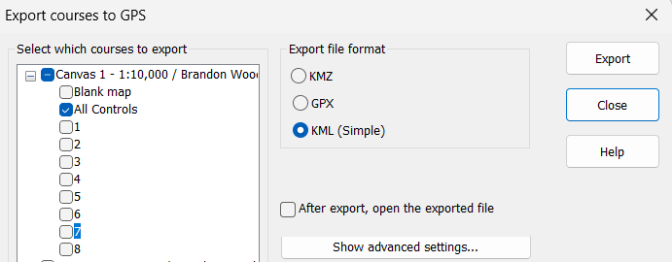
Combined with a blank map KMZ file (from OCAD 10 or newer) there is the option to upload the all-controls map to MapRun CheckSites and use MapRun on a phone to show both control locations and your current position.
In all instances, the usefulness of these methods will depend on the location accuracy of the device – which varies widely – and also to an extent the location settings on the device.

Acknowledgements
This document has been prepared by:
Bruce Bryant, OD and Map Advisory Group (OCAD Sketch, Exporting a KMZ from OCAD, Garmin Devices, Garmin Watches, MapRun)
Mark Light, SOC (Loading KMZ file to Garmin devices)
Terry Smith, SOC and Map Advisory Group
Feedback, suggestions and comments may be sent to: mailto:mapchair@britishorienteering.org.uk.

