
EVENT EMERGENCY PROCEDURES

IF YOU ARE DEALING WITH AN EMERGENCY SITUATION JUMP STRAIGHT TO THE RELEVANT COLOUR CODED SECTION:
LOST CHILD (HANDED IN OR REPORTED)
MISSING COMPETITOR
SEARCH PROCEDURE
INJURED PERSON PROCEDURE
MAJOR INCIDENT PROCEDURE
CLOSING DOWN AN INCIDENT
SEARCHER CHECK OUT / IN RECORDS
BRIEFING CARDS FOR SEARCHERS

CONTENTS:
PLANNING AHEAD – WHAT THESE PROCEDURES ASSUME YOU WILL HAVE DONE IN ADVANCE
PLANNING AHEAD – WHAT EQUIPMENT THESE PROCEDURES ASSUME YOU WILL HAVE AVAILABLE
COLOUR CODED EMERGENCY PROCEDURES AS ABOVE
(these are designed to be laminated and written on with a sharpie pen then photographed for a permanent record before cleaning ready for reuse using alcohol hand gel)

PLANNING AHEAD – WHAT THESE PROCEDURES ASSUME YOU WILL HAVE DONE IN ADVANCE
ADVANCE PLANNING ACTIVITY | LARGE EVENT | TYPICAL CLUB LOCAL EVENT | SMALL ACTIVITY  (e.g. club night, coaching)
Risk Assessment
Identified who will adopt which role in an emergency  (e.g. overall incident controller, control of search, control of remainder of event, communications) | Likely to be separate pre-determined roles  e.g. Safety officer = incident controller  Planner in charge of search  Organiser in charge of remainder of event  Enquiries team in charge of communciation | Likely to be organiser in overall control, delegating to others from the pre-identified volunteers | Likely to be organiser / coach in overall control, delegating to other adults present at the activity (ensure sufficient adults are present or can be called on)
Identified nearest A&E
Check opening hours and x-ray availability
Make available maps showing directions, hospital phone number etc
Arranged first aid cover | External provider or teams of experienced qualified orienteers  Communicated with local authority Safety Advisory Group  Ensure that if a commercial provider, is willing and capable of reaching all parts of terrain. Not all are! | Depending on size / type of event may be external, club first aiders or just first aid kit available | First aid kit available
Identified potential access points to area for emergency services / air ambulance (map + grid references / What3Words / postcodes as appropriate) | Access point details on map.  Plan in place for holding any runners who would cross air ambulance landing area | Access point details on map.  Plan in place for holding any runners who would cross air ambulance landing area | Access point details on map.  Plan in place for holding any runners who would cross air ambulance landing area
Plan for allowing access to emergency vehicles  (arrangements to have gate keys present on site, arrangements for holding traffic on narrow lanes, etc). | Know who will hold any keys, where they will be and how to contact them  May also involve fire break / fire engine access lanes in car parking areas | Know who will hold any keys, where they will be and how to contact them | Know who will hold any keys, where they will be and how to contact them
Identified how competitors will be accounted for | Electronic timing  Course closure times  Ability to query for ‘late’ participants during the event where there is a long start window | Electronic timing  Course closure times  Ability to query for ‘late’ participants during the event where there is a long start window | Check in/out sheets if not electronically timed.  Set expectations for return time
Identified who will be available to help in the event of an emergency / in the event of a search being required  (noting that these people should not already be allocated to other vital duties such as first aid or download) | Organiser has list of willing volunteers, with phone numbers, and their roles | Organiser has list of willing volunteers, with phone numbers, and their roles | May be a list of club volunteers willing to be called out if needed
Identified how individual participants can communicate with officials in an emergency | Emergency number on the map / bibs  Phone manned by enquiries team | Emergency number on the map  Phone manned by download team | Emergency number on the map  Phone manned by person leading activity (ensure full charge)
Identified how officials can communicate with individual participants in an emergency | Phone numbers collected during online registration process  Participants recommended to carry phones  Registration process includes possibility of registering whether they have GPS tracking enabled | Phone numbers collected during online registration process  Participants recommended to carry phones  Registration process includes possibility of registering whether they have GPS tracking enabled | Phone numbers / details of any GPS tracking collected during online registration process or exchanged on the day
Identified how officials will communicate with each other in an emergency  Tests of mobile phone coverage and radio coverage to be carried out before the event. | Event officials and volunteers all have emergency number and other key numbers in phones and have What3Words / OS Maps Apps installed.  Laminated lists of phone numbers distributed  Radios for key official / marshals | Event officials all have emergency number in phones and have What3Words / OS Maps Apps installed.  Laminated list of phone numbers if officials / marshals in remote locations.  Download team provided with phone numbers for event officials | All of those involved in organising (minimum 2) have fully charged phones, have shared phone numbers with each other and have What3Words / OS Maps Apps installed
Planned for evacuation of any indoor areas
(check permitted fire occupancy, alarm points, fire exit doors which must be kept clear e.g. of clothing dumps, fire protection doors which must remain closed, muster points, roll call lists or marshals trained in how to sweep in use areas)
Considered any additional mitigations required because of likely weather conditions (separate guidance available)
Communicated in advance expectations over:
- Mandatory equipment
- Whistles
- Mobile Phones
- GPS tracking devices
- Communication of information about medical conditions
Planned for search of competition areas – maps for use in search | Spare copies of each course map  Suggest 25 spare all controls maps. Consider whether maps with pre-marked search areas are appropriate.  OS maps of area to allow perimeter roads search if reception unlikely to support google maps | Spare copies of each course map  Suggest 5 spare all controls maps and collect used maps from other competitors if more needed  OS maps of area to allow perimeter roads search if reception unlikely to support google maps | Spare copies of each course map  Suggest 5 spare all controls maps and collect used maps from other competitors if more needed  OS maps of area to allow perimeter roads search if reception unlikely to support google maps
Planned for search of competition areas – pre-prepared equipment | Searcher briefing cards (pre-customised with event detail) from blue section of this document)  Pre-prepared emergency grab bags (compass, whistle, windup torch, high vis jacket, foil blanket, notepad and pencil, basic first aid kit)  Stickers / pens for labelling control stakes if control boxes are being collected  Water/high calorie energy food such as Kendal mint cake or Mars Bars for volunteers themselves and also for missing person when found, especially for inhospitable areas | Searcher briefing cards (from blue section of this document)  Pre-prepared emergency grab bags (compass, whistle, windup torch, high vis jacket, foil blanket, notepad and pencil, basic first aid kit)  Stickers / pens for labelling control stakes if control boxes are being collected | Searcher briefing cards (from blue section of this document)  Those organising to ensure they (and anyone they call out to help) come with required items to go out searching

PLANNING AHEAD – WHAT EQUIPMENT THESE PROCEDURES ASSUME YOU WILL HAVE AVAILABLE
EQUIPMENT | LARGE EVENT | TYPICAL CLUB EVENT | SMALL ACTIVITY
Copies of information from the planning phase:
- Risk Assessment
- Details of nearest A&E
- Detail of access points
- Phone contact lists
- Spare copies of maps
- OS maps if needed
Copies of colour coded procedures from this document
Sharpie pens for recording onto them
First aid equipment | Likely to include ambulances and vehicles able to access into the terrain / first aid points / defibrillator  Emergency shelter  Consider lightweight stretcher | First aid kit, possibly including defibrillator  Emergency shelter | First aid kit
Fire safety equipment | Likely to include fire points, fire extinguishing equipment for marquees / car park areas / food traders, roll call lists for volunteers, roll call lists for those sleeping over (e.g. at PPR) | May require fire extinguishers suitable for equipment in use if indoor venues do not provide them or if generators are in use | Unlikely to be needed
Equipment necessary to identify missing competitors | Electronic timing | Electronic timing | Check in/out sheets if not electronically timed
Communication equipment | Emergency phone  Radios if in area with poor phone reception  PA system (commentary team) | Emergency phone  Radios if in area with poor reception | Organiser’s mobile phone  Radios if in area with poor phone reception
Search equipment | Searcher briefing cards (from blue section of this document)  Pre-marked all control maps if appropriate  Pre-prepared emergency grab bags (compass, whistle, windup torch, high vis jacket, foil blanket, notepad and pencil, basic first aid kit)  Stickers / pens for labelling control stakes if control boxes are being collected  Water, food as above | Searcher briefing cards (from blue section of this document)  Pre-prepared emergency grab bags (compass, whistle, windup torch, high vis jacket, foil blanket, notepad and pencil, basic first aid kit)  Stickers / pens for labelling control stakes if control boxes are being collected | Searcher briefing cards (from blue section of this document)  Those organising to ensure they (and anyone they call out to help) come with required items
Other equipment | Black and yellow hazard tape to use for hazards or cordoning off areas | Black and yellow hazard tape to use for hazards or cordoning off areas | Black and yellow hazard tape to use for hazards or cordoning off areas

LOST CHILD After use, take a photo for the incident records before wiping clean using hand gel
IF CHILD IS FOUND SEPARATED FROM THEIR CARERS
Current time | Child’s name | Child’s age | Any contact details for family who may not be present at the event
Where/when did the child last see their parent or carer? | Parent or carer’s name | Parent or carer’s phone number | Orienteering club
Any other relevant details such as what carers/parents might be wearing for easy identification?

SEARCHING FOR THE PARENTS OR CARERS
Name of adult nominated to care for child during search for the parents | Location where they will sit with the child | Nominated adult’s phone number | Nominated adult’s orienteering club
Phoned the parent/carer’s mobile number?  (if the child does not know it, this may be available from the SI team if registered during event entry or for EOD dibber hire) |  |  | TIME:
At a large event – commentary team put out call asking parent/carer to come to enquiries?  (note that the child's full name should NOT be broadcast - use parent's name if child is old enough to communicate this; use child's first name and a brief description if not) |  |  | TIME:
Checked club tent?  (ask if any club members have seen them / know where they are / know contact details for them) |  |  | TIME:
Checked with SI to see if parent / carer is known to be out on course?  . |  |  | TIME:
HAND BACK OF CHILD
DO NOT HAND A CHILD TO ANY ADULT THAT THEY DO NOT RECOGNISE AND SAY THEY ARE HAPPY TO GO WITH – CALL EVENT ORGANISER IF THERE IS ANY DOUBT
Name of adult child handed back to | Relationship to child | Phone number of adult | Orienteering club of adult
Time of handover | Address of adult

LOST CHILD After use, take a photo for the incident records before wiping clean using hand gel
IF CHILD IS BEING REPORTED MISSING
Current time | Child’s name | Child’s age | Any GPS tracking enabled?
Child’s phone number | What are they wearing? | What do they look like?  (parent may have a photo that can be shared) | Carrying a whistle?
Where/when was the child last seen? | Parent or carer’s name | Parent or carer’s phone number | Orienteering club
Any other relevant details (e.g. medical or neurodiverse conditions)

SEARCHING FOR THE CHILD IN THE ASSEMBLY AREAS
IF CHILD IS BELIEVED TO BE OUT ON A COURSE GO TO THE MISSING COMPETITOR PROCEDURE (GREEN HEADED SHEETS)
Phoned their mobile number?  (Likely to be known by the parent, of if being reported by someone else this may be available from the SI team if registered during event entry or for EOD dibber hire) |  |  | TIME:
Checked whether they have any form of GPS tracking enabled via close contacts that could confirm their location? |  |  | TIME:
Checked with SI to see if they are out on course?  . |  |  | TIME:
At a large event - commentary team put out call asking them to come to enquiries?  (note that the child's full name should NOT be broadcast - use parent's name if child is old enough to communicate this; use child's first name and a brief description if not) |  |  | TIME:
Checked club tent?  (ask if any club members have seen them / know where they are / know contact details for them) |  |  | TIME:
Checked toilets?  . |  |  | TIME:
Checked car park?  . |  |  | TIME:
Passed details to event officials / marshals and asked them to actively look out for the child?  . |  |  | TIME:
Sent marshal + parent back to the point they were last seen to look for 10 minutes then return?  . |  |  | TIME:
Informed police on non-emergency number 101 that we have a missing child for whom we are still searching?  (Do this straight away if none of the above succeed in locating the child) |  |  | TIME:  REF NO:
Organised sweep of assembly areas looking for child (record searcher details on blue search form)?  . |  |  | TIME:
Requested help from police? (Do this if sweep of areas fails to locate the child within or is still in progress after an hour)  Informed British Orienteering 01629 583037 / 07384 462432 of missing child situation? |  |  | TIME:
Child found  . |  |  | TIME:
Informed all those who were involved in search to stand down?  (officials / marshals / searchers / police / British Orienteering…) |  |  | TIME:

MISSING COMPETITOR After use, take a photo for the incident records before wiping clean using hand gel
ABOUT THE MISSING PERSON
Current time | Name | Address | Age Group (e.g. W10, M80)
Appearance / clothing?  (parent or friend may have a photo that can be shared) | Carrying a phone?  Phone number: | Carrying a whistle? | SIAC or punching dibber?
Which course are they on? | What time did they set out?  How late are they? | Any known medical or neurodiverse conditions, mobility issues or dementia? | Level of orienteering experience?
Car details (colour, type, reg) | What time did they set out | When might they have been expected back? | How late are they?
Any other relevant details

ARE WE SURE THEY ARE REALLY MISSING OUT IN A COURSE?
IF IT IS A CHILD, ENSURE ONE PARENT/CARER REMAINS AT DOWNLOAD TO BE THERE IF THEY DO APPEAR
Phoned their mobile number?  (this may be available from the SI team if registered during event entry or for EOD dibber hire) |  |  | TIME:
Checked whether they have any form of GPS tracking enabled via close contacts that could confirm their location?  (this may be available from the SI team if information registered during event entry or by phoning the ICE number they registered or by asking if family or other club members know)  If GPS tracking in use, check location and rate of progress, If participant is not moving and cannot be contacted, assume injury and jump to ORANGE HEADED SHEETS |  |  | TIME:
Checked that they did actually start?  (Check with SI Team - check start list or any information from radio start control or swap out and interrogate start control) |  |  | TIME:
Checked that they really haven’t finished?  (Check with SI Team, check with enquiries team if event is operating a car key deposit locaion) |  |  | TIME:
Checked progress around course via any GPS controls which might be on their course?  (Check with SI Team) |  |  | TIME:
Commentary team put out call put out asking them to come to enquiries if they haven’t yet downloaded? |  |  | TIME:
Checked club tent?  (ask if any club members have seen them / know where they are / know contact details for them) |  |  | TIME:
Checked toilets?  (ask if any club members have seen them / know where they are / know contact details for them) |  |  | TIME:
Checked car park?  (are they in their car? Is their car still present?) |  |  | TIME:
Checked with officials or marshals who might have seen them?  (e.g. road crossing marshals? ) |  |  | TIME:
DO WE NEED TO START SEARCHING FOR THEM?
Review (and continue to review) whether a search should be started. Record time and decision for each review.  Consider:  Participant details (age, known medical conditions, age, experience)  Conditions they are out in (terrain, weather conditions, temperature)  Likely difficulty of finding them (terrain, conditions, amount of daylight left, density of competitors still out, whether they have a whistle / phone / GPS tracking)  IF SEARCH IS REQUIRED, GO TO THE SEARCH PROCEDURE (YELLOW HEADED SHEETS) |  |  | TIME/DECISION

SEARCH PROCEDURE After use, take a photo for the incident records before wiping clean using hand gel
PREPARING FOR A SEARCH (check all items on green Missing Persons sheet have been tried first)
Called in identified searchers?  (Ask enquiries team to do this at a large event - refer to communications list for the event and/or club volunteers list for a small activity) |  |  |  |  |  |  | TIME:
Asked for experienced orienteers from the person’s own club who would recognise them?  (Try club tent at a large event; ask around assembly area at a small event) |  |  |  |  |  |  | TIME:
Ensure friends / family are being looked after – if it is a child who is missing keep one parent/carer at download |  |  |  |  |  |  | TIME:
Do not collect control flags whilst lost competitors may be reliant on them to relocate  (If it is after event closing, the control boxes may be collected to interrogate for punches but stakes and flags should be left – there are stickers available to allow stakes to be labelled with the correct control numbers o aid relocation) |  |  |  |  |  |  | TIME:
Collect spare maps. Keep one for use as master on which areas searched will be marked up.  Prepare maps which will be needed by searchers and mark up with search routes / areas. |  |  |  |  |  |  | TIME:
Collect any keys for access routes held by the organiser. |  |  |  |  |  |  | TIME:
Ensure searchers have had chance to tell own family they may be late back |  |  |  |  |  |  | TIME:
Ensure searchers are adequately prepared  Searcher briefing card (event phone numbers, basic instructions)  Suitable clothing for their own protection and comfort, own spectacles, any equipment such as inhalers they would normally carry.  Details of the person they are looking for – can a photo be shared?  Means of communication – record mobile numbers on blue headed searcher details sheets; check What3Words / OS Map apps installed on phones for use if reception permits  Map showing search route (consider adding grid markings for ease of describing current location - there are red pens in resources in case courses need to be hand copied onto maps)  Emergency pack (compass, whistle, windup torch, high vis jacket, foil blanket, notepad and pencil, basic first aid kit and food/drink)  Stickers and marker pens for labelling control stakes if control boxes are being collected |  |  |  |  |  |  | TIME:
INITIAL SEARCH
RECORD SEARCHER DETAILS AND TIMES OUT/IN ON BLUE HEADED SHEETS
RECORD AREAS SEARCHED ON MASTER MAP
PAIR UP SEARCHERS TO INCLUDE FAMILIARITY WITH THE AREA / RECOGNITION OF THE MISSING PERSON / FIRST AID CAPABILITY
Consider informing police on non-emergency 101 number that we have a missing competitor we are about to start searching for  (definitely do this now if a child or other vulnerable person is out in extreme weather or after dark) |  |  |  |  |  |  | TIME:  REF NO:
Send a pair of searchers (white / yellow courses) or group of searchers (courses with significant route choice) round the course in reverse to look for the person / ask other competitors for sightings / listen for emergency whistle signals |  |  |  |  |  |  | (record time out/in on search sheet)
If not found, now definitely inform police on non-emergency 101 number that we have a missing competitor we still searching for  If not found and the missing person is aged under 18, inform British Orienteering 01629 583037 (office) / 07384 462432 (out of hours). Agree timeframe with police for calling back with a progress report (timeframe likely to depend on competitor vulnerability, terrain, weather, hours of daylight remaining…)  If found, inform all those who were involved in search to stand down (officials / marshals / searchers / police…)  IF YOU ARE NOW DEALING WITH A CASUALTY SITUATION GO TO THE INJURED PERSON PROCEDURE (ORANGE HEADED SHEETS) |  |  |  |  |  |  | TIME:  REF NO:  Agreed time at which progress will be reported to police:  Agreed number to use:
Send a pair of searchers to drive any perimeter roads and any other roads in the mapped area – take any access route keys, google maps / OS map of area |  |  |  |  |  |  | (record time out/in on search sheet)
Send a pair of searchers to check the likely route participant would have taken if using the safety bearing |  |  |  |  |  |  | (record time out/in on search sheet)
If not found within agreed timeframe, escalate with police via 101 or 999 as agreed in previous call and request assistance  If not found within agreed timeframe, inform British Orienteering 01629 583037 (office) / 07384 462432 (out of hours)  If not found, consider any other parties who may need to be informed – e.g. land owner  If found, inform all those who were involved in search to stand down (officials / marshals / searchers / police / British Orienteering…)  IF YOU ARE NOW DEALING WITH A CASUALTY SITUATION GO TO THE INJURED PERSON PROCEDURE (ORANGE HEADED SHEETS) |  |  |  |  |  |  | TIME:
CONTINUE SEARCH – POLICE WILL LIKELY TAKE CHARGE ON ARRIVAL BUT CONTINUE SEARCH AS FOLLOWS UNTIL TOLD OHERWISE
RECORD SEARCHER DETAILS AND TIMES OUT/IN ON BLUE HEADED SHEETS
RECORD AREAS SEARCHED ON MASTER MAP
IDEALLY PAIR UP SEARCHERS TO INCLUDE FAMILIARITY WITH THE AREA / RECOGNITION OF THE MISSING PERSON / FIRST AID CAPABILITY
Continue to consider welfare needs of searchers – have they had access to food and drink, are they warm enough, are they tired enough to need replacing by others…
Prioritise areas to search based on likelihood of them being the competitor’s location:  - vicinity of any reported sightings  - vicinity of last reported position from any GPS tracking which might be enabled  - area between the last missed control and the next control if identifiable for a competitor using a punching dibber  - areas which form a likely route choice for their course  - areas which present specific hazards (steep slopes / crags, water / marshes)  - other areas in proximity to their course  - areas they would have had to be seriously lost to end up in |  |  |  |  |  |  | (mark up identified search areas on master map)
Send pairs of searchers to do a ribbon search of the identified areas in order of likelihood – following paths or other linear features, scanning area either side, listening for whistle signals. E.g. for a competitor last seen at control 1 below and heading for control 2 approx 400m away, a ribbon search along the paths highlighted pink would be a logical initial search:  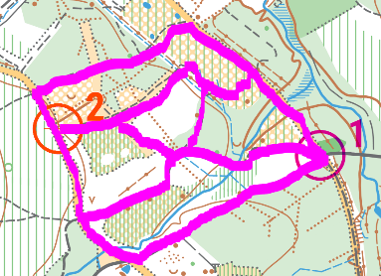  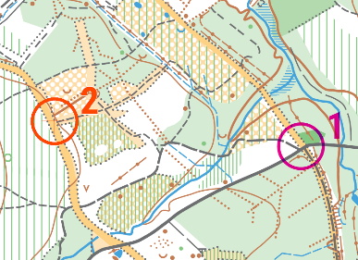  - It takes searchers within 50m of every point (120dB whistle at 50m is roughly the loudness of a shout so should be heard; a 85dB shout at 50m is the loudness of a quiet conversation so also has some chance of being picked up if searchers are listening for it)  - It covers all of the paths (more likely route choice than areas of undergrowth or ‘walk’ forest)  - In the runnable forest areas (the next most likely route choices) the searchers will have been able to see 40+m into the forest, giving them a good chance of identifying a person in colourful clothes |  |  |  |  |  |  | (record time out/in on search sheet) (mark up search routes on master map)
If ribbon searches do not locate the missing person, more searchers will be needed to perform a sweep search – searchers spaced out in a line walk across the terrain scanning for the missing person..  Again, prioritise areas based on likelihood (both of location and of route choice).  Allocate searchers based on the terrain  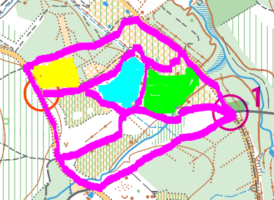  e.g. if we are prioritising the area near the last known position, the open area highlighted yellow can likely be covered by a smaller number of searchers than the runnable forest area highlighted blue; the ‘slow run’ forest area highlighted green would require many more.  Prioritising the ‘run’ and ‘open’ areas makes sense as they are both quicker to search and a more logical route choice than the thick undergrowth or ‘walk’ areas.  The next page includes some sample pictures of what 25m looks like in different vegetation types on relatively flat ground to give an idea of the number of searchers that will be required. |  |  |  |  |  |  | (record time out/in on search sheet)
Record time at which control handed to emergency services |  |  |  |  |  |  | TIME:
Record time at which missing person found  IF YOU ARE NOW DEALING WITH A CASUALTY SITUATION GO TO THE INJURED PERSON PROCEDURE (ORANGE HEADED SHEETS) |  |  |  |  |  |  | TIME:
Additional useful information for search organisers – visibility in different types of vegetation
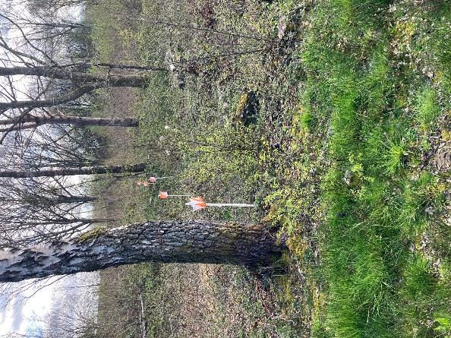  Forest with undergrowth  Can see 25m at 1m height  but only 10m at ground level  Visibility of a fallen casualty likely to be limited by vegetation  Likely to need searchers no more than 10-20m apart |  | 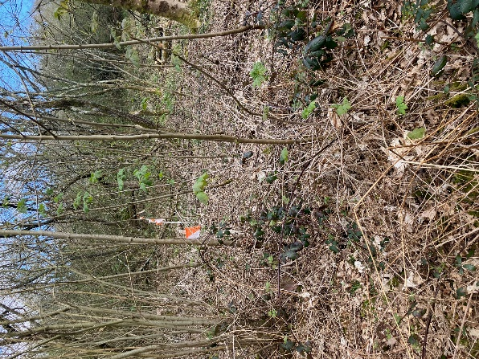  Forest ‘walk’  Can see 25m at 1m height  but only 10m at ground level  Visibility of a fallen casualty likely to be limited by vegetation  Likely to need searchers no more than 10-20m apart |  | 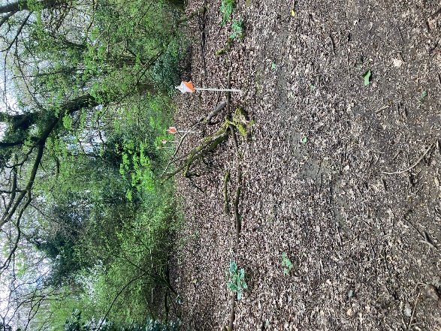  Forest ‘slow run’’  Can see 25m at 1m height and around 20m at ground level with occasional interruption from thickets or undergrowth  Visibility of a fallen casualty dependent on both vegetation and contour detail or mapped obstacles  Likely to need searchers no more than 20-30m apart |  | 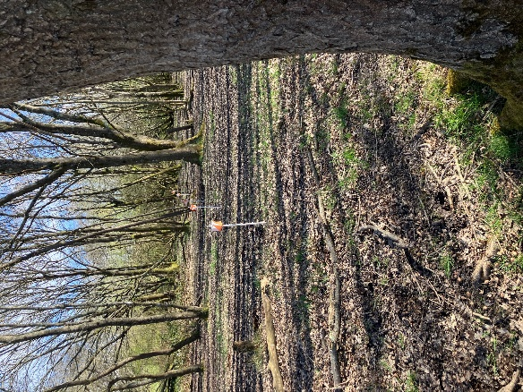  Forest ‘run’  Can see 40m+ at 1m height and similar at ground level. More than this starts to be obstructed by tree trunks  Visibility of casualty mostly dependent on contour detail or mapped obstacles  Likely to need searchers around 50m apart if flat; closer if there are lots of contour details or thickets |  |  | 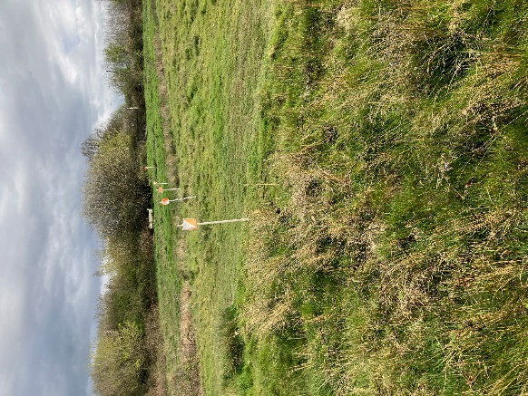  Open or rough open ground  Can see 100m+ at 1m height and similar at ground level.  Visibility of casualty mostly dependent on contour detail or mapped obstacles  Likely to need searchers around 100m apart if flat; closer if there are lots of contour details or thickets
Additional useful information for search organisers – how far away are we likely to hear a shout or a whistle?
120dB | Emergency whistle – right next to it |  |  |  | Similar loudness to a jet plane taking off |  |  | Definitely hear it!
100dB | Emergency whistle – at 10m |  |  |  | Similar loudness to a motorcycle revving |  |  | Definitely hear it!
90dB | Emergency whistle – at 30m |  | Very loud shout – right next to it |  | Similar loudness to power tools |  |  | Definitely hear it!
80dB | Emergency whistle – at 100m |  | Very loud shout – at 3m |  | Similar loudness to a noisy restaurant |  |  | Definitely hear it!
70dB | Emergency whistle – at 300m |  | Very loud shout – at 10m |  | Similar loudness to general traffic |  |  | Likely to hear it
60dB | Emergency whistle – at 1000m |  | Very loud shout – at 30m |  | Similar loudness to a normal conversation |  |  | Should hear if listening carefully
50dB | Emergency whistle – at 3000m |  | Very loud shout – at 100m |  | Similar loudness to rainfall / noise from a stream |  |  | Unlikely to hear

INJURED PERSON PROCEDURE After use, take a photo for the incident records before wiping clean using hand gel
DETAILS FROM THE INITIAL REPORT OF A CASUALTY
Current time | Location of casualty | Condition of casualty | Reported in by (name, phone number, club)
ABOUT THE CASUALTY (record whatever is known and come back once first aid is underway)
Name | Address | Next of kin details | Known medical or neurodiverse conditions?
Age Group (e.g. W10, M80) | Club
GETTING FIRST AID TO THE CASUALTY
Decide the best arrival point for first aid / emergency services  (Details of potential emergency access routes will be in the event risk assessment) |  |  | Location (e.g. What3Words)
If initial assessment is that emergency services are required, phone 999 and agree arrival point for 4x4 ambulance or air ambulance |  |  | TIME:
Send first aid party to location of casualty (they may escalate to a 999 situation on arrival if this is not already the case)  - Consider fastest access route – may include use of on road / 4x4 vehicles  - Provide any keys required for access routes  - Provide map with casualty location marked + What3Words / grid reference location  - Provide any known details of casualty (e.g. medical conditions)  - Send first aid equipment, warm clothing, food and drink, emergency shelter  - Ensure members of party are properly equipped themselves and are signed out/in on blue searcher sheets  Searcher briefing card (event phone numbers, basic instructions)  Suitable clothing for their own protection and comfort, own spectacles, any equipment such as inhalers they would normally carry.  Means of communication – record mobile numbers on blue headed searcher details sheets; check What3Words / OS Map apps installed on phones for use if reception permits  Emergency pack (compass, whistle, windup torch, high vis jacket, foil blanket, notepad and pencil, basic first aid kit) |  |  | (record time out/in on search sheet)
Send party to meet emergency services  - Provide any keys required for access routes  - Provide map with casualty location marked + What3Words / grid reference location  - Ensure members of party are properly equipped themselves and are signed out/in on blue searcher sheets  Searcher briefing card (event phone numbers, basic instructions)  Suitable clothing for their own protection and comfort, own spectacles, any equipment such as inhalers they would normally carry.  Means of communication – record mobile numbers on blue headed searcher details sheets; check What3Words / OS Map apps installed on phones for use if reception permits  Emergency pack (compass, whistle, windup torch, high vis jacket, foil blanket, notepad and pencil, basic first aid kit) |  |  | (record time out/in on search sheet)
Make any other arrangements necessary to allow emergency access – e.g. holding traffic on one way access roads, clearing air ambulance landing area, sending marshals to divert runners around the casualty, the planned extraction route air, any ambulance landing area. |  |  | TIME:
CONSIDER WHETHER ESCALATION TO MAJOR INCIDENT IS REQUIRED (RED HEADED SHEETS IN ADDITION TO CONTINUING BELOW) |  |  | YES/NO
SUPPORTING AND RECOVERING THE CASUALTY
Send additional helpers as requested by first aiders / emergency services to support including in any of the following ways  - Assist with emergency shelter  - Assist with diverting other competitors around the scene  - Assist with recovery of casualty  - Ensure those sent out are properly equipped themselves and are signed out/in on blue searcher sheets  Searcher briefing card (event phone numbers, basic instructions)  Suitable clothing for their own protection and comfort, own spectacles, any equipment such as inhalers they would normally carry.  Means of communication – record mobile numbers on blue headed searcher details sheets; check What3Words / OS Map apps installed on phones for use if reception permits  Emergency pack (compass, whistle, windup torch, high vis jacket, foil blanket, notepad and pencil, basic first aid kit) |  |  | (record time out/in on search sheet)
Ensure friends / family are being looked after  . |  |  | TIME:
Arrange to get information from emergency services about where casualty is being taken |  |  | TIME:  HOSPITAL:
Arrange to contact other people who need to know:  - Next of kin  - British Orienteering 01629 583037 (office) / 07384 462432 (out of hours) if a death or major injury has occurred  - Land owners  . |  |  | TIME:
Make arrangements for return of items (including vehicles) belonging to the casualty |  |  | DETAILS OF ARRANGEMENTS:

MAJOR INCIDENT PROCEDURE After use, take a photo for the incident records before wiping clean using hand gel
Applies to:
- Fatality or major injury
- Fire
- Collapse of event infrastructure such as marquee
- Major violence or terrorism
- Loss of event access routes
- Any other situation which puts participants, volunteers or spectators at serious risk
INITIAL INCIDENT DETAILS
Current time | Nature of incident | Number / condition of casualties |  | Reported in by (name, phone number, club)
CALL FOR HELP
Phone 999, describe location and nature of incident and agree arrival point for emergency services  (Details of potential emergency access routes will be in the event risk assessment) |  |  | TIME:  REF:  ARRIVAL LOCATION:
If there are people in immediate danger (e.g. from fire), use whatever means are available to alert them (alarm, commentary PA system, shout) and remove them from the source of danger |  |  | (record time out/in on search sheet)
Send party to meet emergency services  - Provide any keys required for access routes  - Provide map with incident location marked + What3Words / grid reference location  - Ensure members of party are properly equipped themselves and are signed out/in on blue searcher sheets  Searcher briefing card (event phone numbers, basic instructions)  Suitable clothing for their own protection and comfort, own spectacles, any equipment such as inhalers they would normally carry.  Means of communication – record mobile numbers on blue headed searcher details sheets; check What3Words / OS Map apps installed on phones for use if reception permits  Emergency pack (compass, whistle, windup torch, high vis jacket, foil blanket, notepad and pencil, basic first aid kit) |  |  | (record time out/in on search sheet)
Make any other arrangements necessary to allow emergency access – e.g. holding traffic on one way access roads, clearing air ambulance landing area |  |  | TIME:
TAKE INITIAL STEPS TO CONTAIN INCIDENT IF POSSIBLE
CASUALTIES  If local first aiders are available and it is safe to do so, send them to assist casualties  (DELEGATE SOMEONE TO OVERSEE THIS AND RECORD DETAILS AS PER ORANGE HEADED SHEETS) |  |  | (record time out/in on search sheet)
FIRE
- Tell people to leave the area
- Tell anyone operating electrical or cooking equipment to turn it off before leaving if they can do so safely
- Turn off electrical / gas supplies at isolation point if possible
- Ask volunteers to establish a cordon
  - 20m from edge of combustible material
  - 50m from a vehicle or petrol generator fire
SET UP CONTROL POINT AND ALLOCATE ROLES
Set up an emergency control point  - Organiser should adopt role of emergency coordinator unless role has been delegated to safety officer at a large event.  - At a small local event download is likely to be the only tented area  - At a large event, a preferred location should be pre-allocated by the organiser |  |  | Name of coordinator  Location of control point  Time
Consider the need for the following roles and ensure communications is set up between these people |  |  | Name |  | Mobile number
- Someone to identify / contact next of kin and look after them
- Someone to coordinate with emergency services
- Someone to coordinate with British Orienteering
- Someone to deal with other people in the area (taping off, cordons, etc)
- Someone to deal with managing the remainder of the event (preventing anyone else starting, registering returning runners, etc)
- Someone to look after volunteers involved in managing the emergency (briefing them, monitoring how they are coping, providing shelter / food / drink)
CONTINUE TO MANAGE SITUATION AND COORDINATE WITH EMERGENCY SERVICES
Time at which control handed to emergency services: |  |  | TIME
Record details of those involved in or witnessing the incident (add sheets if needed)

Continue to log detail of actions taken (add sheets if needed)

Ensure logs and details of those involved in dealing with the incident are kept
Instruct everyone to refer media enquiries to the police
Remind all personnel not to pass on any names and information until next of kin informed and the release of this information has been agreed with Police and Chief Executive
CLOSE DOWN INCIDENT (AS PER GREY HEADED SHEETS)

CLOSING DOWN AN INCIDENT After use, take a photo for the incident records before wiping clean using hand gel
Call any searchers or other helpers who are still out to tell them they can return | TIME:
Confirm all searchers and other helpers have returned safely | TIME:
Update all other parties involved  - Police / emergency services (in person or 101)  - Family of missing persons / casualties  - Families of searchers  - Land owner  - British Orienteering Office / Chief Executive | TIME:
DEBRIEFING VOLUNTEERS
Thank everyone involved for their support

Collect information / write reports whilst circumstances are fresh in people's minds
What worked? What didn’t work? What caused delays?

Ensure logs and any other information is collected in
Remind all personnel not to pass on any names and information until next of kin informed and the release of this information has been agreed with Police and Chief Executive. All approaches from the media should be directed to the Police and the Chief Executive warned
FORMAL REPORTING
Complete British Orienteering incident report and provide any other information requested
ONGOING SUPPORT
Liaise with British Orienteering over ongoing support for those who might have been involved in something traumatic

SEARCHER CHECK OUT / IN RECORDS After use, take a photo for the incident records before wiping clean using hand gel
Names | Mobile phone number | Equipment issued | Search Area | Time Out | Time Back

BRIEFING CARD FOR SEARCHERS | BRIEFING CARD FOR SEARCHERS | BRIEFING CARD FOR SEARCHERS
LOOK AFTER YOUR OWN SAFETY FIRST! | LOOK AFTER YOUR OWN SAFETY FIRST! | LOOK AFTER YOUR OWN SAFETY FIRST!
THINGS TO TAKE WITH YOU  Suitable clothing for your own protection and comfort  Means of communication, whistle  Compass + map(s) showing search area  Emergency grab bag (if one available)  Additional jacket, food, water for casualty if found  Head torch if nearing dusk  Own spectacles if needed | THINGS TO TAKE WITH YOU  Suitable clothing for your own protection and comfort  Means of communication, whistle  Compass + map(s) showing search area  Emergency grab bag (if one available)  Additional jacket, food, water for casualty if found  Head torch if nearing dusk  Own spectacles if needed | THINGS TO TAKE WITH YOU  Suitable clothing for your own protection and comfort  Means of communication, whistle  Compass + map(s) showing search area  Emergency grab bag (if one available)  Additional jacket, food, water for casualty if found  Head torch if nearing dusk  Own spectacles if needed
ON FINDING MISSING PERSON  Approach sympathetically using their name and offering reassurance  If all ok (or incident can be handled by finder only) – two blasts on the whistle – radio/phone situation to safety coordinator. Finder bring lost person back.  If extra help needed – six blasts on whistle (repeated as necessary) – search team muster at finders location, report to safety coordinator (grid reference, whether ambulance help required etc.).  Offer first aid using contents of the grab bag if you are confident to do so.  Only attempt to move the casualty if you can do so without exacerbating any injury and without any risk to the search team | ON FINDING MISSING PERSON  Approach sympathetically using their name and offering reassurance  If all ok (or incident can be handled by finder only) – two blasts on the whistle – radio/phone situation to safety coordinator. Finder bring lost person back.  If extra help needed – six blasts on whistle (repeated as necessary) – search team muster at finders location, report to safety coordinator (grid reference, whether ambulance help required etc.).  Offer first aid using contents of the grab bag if you are confident to do so.  Only attempt to move the casualty if you can do so without exacerbating any injury and without any risk to the search team | ON FINDING MISSING PERSON  Approach sympathetically using their name and offering reassurance  If all ok (or incident can be handled by finder only) – two blasts on the whistle – radio/phone situation to safety coordinator. Finder bring lost person back.  If extra help needed – six blasts on whistle (repeated as necessary) – search team muster at finders location, report to safety coordinator (grid reference, whether ambulance help required etc.).  Offer first aid using contents of the grab bag if you are confident to do so.  Only attempt to move the casualty if you can do so without exacerbating any injury and without any risk to the search team
Event emergency number:  Organiser:  Planner:  Controller:  SUNSET TODAY IS AT: | Event emergency number:  Organiser:  Planner:  Controller:  SUNSET TODAY IS AT: | Event emergency number:  Organiser:  Planner:  Controller:  SUNSET TODAY IS AT:

BRIEFING CARD FOR SEARCHERS | BRIEFING CARD FOR SEARCHERS | BRIEFING CARD FOR SEARCHERS
LOOK AFTER YOUR OWN SAFETY FIRST! | LOOK AFTER YOUR OWN SAFETY FIRST! | LOOK AFTER YOUR OWN SAFETY FIRST!
THINGS TO TAKE WITH YOU  Suitable clothing for your own protection and comfort  Means of communication, whistle  Compass + map(s) showing search area  Emergency grab bag (if one available)  Additional jacket, food, water for casualty if found  Head torch if nearing dusk  Own spectacles if needed | THINGS TO TAKE WITH YOU  Suitable clothing for your own protection and comfort  Means of communication, whistle  Compass + map(s) showing search area  Emergency grab bag (if one available)  Additional jacket, food, water for casualty if found  Head torch if nearing dusk  Own spectacles if needed | THINGS TO TAKE WITH YOU  Suitable clothing for your own protection and comfort  Means of communication, whistle  Compass + map(s) showing search area  Emergency grab bag (if one available)  Additional jacket, food, water for casualty if found  Head torch if nearing dusk  Own spectacles if needed
ON FINDING MISSING PERSON  Approach sympathetically using their name and offering reassurance  If all ok (or incident can be handled by finder only) – two blasts on the whistle – radio/phone situation to safety coordinator. Finder bring lost person back.  If extra help needed – six blasts on whistle (repeated as necessary) – search team muster at finders location, report to safety coordinator (grid reference, whether ambulance help required etc.).  Offer first aid using contents of the grab bag if you are confident to do so.  Only attempt to move the casualty if you can do so without exacerbating any injury and without any risk to the search team | ON FINDING MISSING PERSON  Approach sympathetically using their name and offering reassurance  If all ok (or incident can be handled by finder only) – two blasts on the whistle – radio/phone situation to safety coordinator. Finder bring lost person back.  If extra help needed – six blasts on whistle (repeated as necessary) – search team muster at finders location, report to safety coordinator (grid reference, whether ambulance help required etc.).  Offer first aid using contents of the grab bag if you are confident to do so.  Only attempt to move the casualty if you can do so without exacerbating any injury and without any risk to the search team | ON FINDING MISSING PERSON  Approach sympathetically using their name and offering reassurance  If all ok (or incident can be handled by finder only) – two blasts on the whistle – radio/phone situation to safety coordinator. Finder bring lost person back.  If extra help needed – six blasts on whistle (repeated as necessary) – search team muster at finders location, report to safety coordinator (grid reference, whether ambulance help required etc.).  Offer first aid using contents of the grab bag if you are confident to do so.  Only attempt to move the casualty if you can do so without exacerbating any injury and without any risk to the search team
Event emergency number:  Organiser:  Planner:  Controller:  SUNSET TODAY IS AT: | Event emergency number:  Organiser:  Planner:  Controller:  SUNSET TODAY IS AT: | Event emergency number:  Organiser:  Planner:  Controller:  SUNSET TODAY IS AT:

BRIEFING CARD FOR SEARCHERS | BRIEFING CARD FOR SEARCHERS | BRIEFING CARD FOR SEARCHERS
LOOK AFTER YOUR OWN SAFETY FIRST! | LOOK AFTER YOUR OWN SAFETY FIRST! | LOOK AFTER YOUR OWN SAFETY FIRST!
THINGS TO TAKE WITH YOU  Suitable clothing for your own protection and comfort  Means of communication, whistle  Compass + map(s) showing search area  Emergency grab bag (if one available)  Additional jacket, food, water for casualty if found  Head torch if nearing dusk  Own spectacles if needed | THINGS TO TAKE WITH YOU  Suitable clothing for your own protection and comfort  Means of communication, whistle  Compass + map(s) showing search area  Emergency grab bag (if one available)  Additional jacket, food, water for casualty if found  Head torch if nearing dusk  Own spectacles if needed | THINGS TO TAKE WITH YOU  Suitable clothing for your own protection and comfort  Means of communication, whistle  Compass + map(s) showing search area  Emergency grab bag (if one available)  Additional jacket, food, water for casualty if found  Head torch if nearing dusk  Own spectacles if needed
ON FINDING MISSING PERSON  Approach sympathetically using their name and offering reassurance  If all ok (or incident can be handled by finder only) – two blasts on the whistle – radio/phone situation to safety coordinator. Finder bring lost person back.  If extra help needed – six blasts on whistle (repeated as necessary) – search team muster at finders location, report to safety coordinator (grid reference, whether ambulance help required etc.).  Offer first aid using contents of the grab bag if you are confident to do so.  Only attempt to move the casualty if you can do so without exacerbating any injury and without any risk to the search team | ON FINDING MISSING PERSON  Approach sympathetically using their name and offering reassurance  If all ok (or incident can be handled by finder only) – two blasts on the whistle – radio/phone situation to safety coordinator. Finder bring lost person back.  If extra help needed – six blasts on whistle (repeated as necessary) – search team muster at finders location, report to safety coordinator (grid reference, whether ambulance help required etc.).  Offer first aid using contents of the grab bag if you are confident to do so.  Only attempt to move the casualty if you can do so without exacerbating any injury and without any risk to the search team | ON FINDING MISSING PERSON  Approach sympathetically using their name and offering reassurance  If all ok (or incident can be handled by finder only) – two blasts on the whistle – radio/phone situation to safety coordinator. Finder bring lost person back.  If extra help needed – six blasts on whistle (repeated as necessary) – search team muster at finders location, report to safety coordinator (grid reference, whether ambulance help required etc.).  Offer first aid using contents of the grab bag if you are confident to do so.  Only attempt to move the casualty if you can do so without exacerbating any injury and without any risk to the search team
Event emergency number:  Organiser:  Planner:  Controller:  SUNSET TODAY IS AT: | Event emergency number:  Organiser:  Planner:  Controller:  SUNSET TODAY IS AT: | Event emergency number:  Organiser:  Planner:  Controller:  SUNSET TODAY IS AT:

BRIEFING CARD FOR SEARCHERS | BRIEFING CARD FOR SEARCHERS | BRIEFING CARD FOR SEARCHERS
LOOK AFTER YOUR OWN SAFETY FIRST! | LOOK AFTER YOUR OWN SAFETY FIRST! | LOOK AFTER YOUR OWN SAFETY FIRST!
THINGS TO TAKE WITH YOU  Suitable clothing for your own protection and comfort  Means of communication, whistle  Compass + map(s) showing search area  Emergency grab bag (if one available)  Additional jacket, food, water for casualty if found  Head torch if nearing dusk  Own spectacles if needed | THINGS TO TAKE WITH YOU  Suitable clothing for your own protection and comfort  Means of communication, whistle  Compass + map(s) showing search area  Emergency grab bag (if one available)  Additional jacket, food, water for casualty if found  Head torch if nearing dusk  Own spectacles if needed | THINGS TO TAKE WITH YOU  Suitable clothing for your own protection and comfort  Means of communication, whistle  Compass + map(s) showing search area  Emergency grab bag (if one available)  Additional jacket, food, water for casualty if found  Head torch if nearing dusk  Own spectacles if needed
ON FINDING MISSING PERSON  Approach sympathetically using their name and offering reassurance  If all ok (or incident can be handled by finder only) – two blasts on the whistle – radio/phone situation to safety coordinator. Finder bring lost person back.  If extra help needed – six blasts on whistle (repeated as necessary) – search team muster at finders location, report to safety coordinator (grid reference, whether ambulance help required etc.).  Offer first aid using contents of the grab bag if you are confident to do so.  Only attempt to move the casualty if you can do so without exacerbating any injury and without any risk to the search team | ON FINDING MISSING PERSON  Approach sympathetically using their name and offering reassurance  If all ok (or incident can be handled by finder only) – two blasts on the whistle – radio/phone situation to safety coordinator. Finder bring lost person back.  If extra help needed – six blasts on whistle (repeated as necessary) – search team muster at finders location, report to safety coordinator (grid reference, whether ambulance help required etc.).  Offer first aid using contents of the grab bag if you are confident to do so.  Only attempt to move the casualty if you can do so without exacerbating any injury and without any risk to the search team | ON FINDING MISSING PERSON  Approach sympathetically using their name and offering reassurance  If all ok (or incident can be handled by finder only) – two blasts on the whistle – radio/phone situation to safety coordinator. Finder bring lost person back.  If extra help needed – six blasts on whistle (repeated as necessary) – search team muster at finders location, report to safety coordinator (grid reference, whether ambulance help required etc.).  Offer first aid using contents of the grab bag if you are confident to do so.  Only attempt to move the casualty if you can do so without exacerbating any injury and without any risk to the search team
Event emergency number:  Organiser:  Planner:  Controller:  SUNSET TODAY IS AT: | Event emergency number:  Organiser:  Planner:  Controller:  SUNSET TODAY IS AT: | Event emergency number:  Organiser:  Planner:  Controller:  SUNSET TODAY IS AT:

