
Event Cancellation / Curtailment – Extreme Heat
General Considerations for advance cancellation / delaying of event
- Consider whether delaying or bringing forward event would allow risk to be avoided – note specific risks section below and assume the default position is to cancel.
- Effect on event safety in terms of damage to infrastructure (buildings, mobile phone network, power network, clean water and sewage services)
- Risks associated with access to/from the event (road closures, dangerous driving conditions)
- Cancel as early as possible. If there is sufficient information in the days before the event, cancel then
Considerations for event curtailment / abandonment
As above list plus
- Ability of participants to get home safely
- Ability to carry out emergency procedures such as searching safely for missing competitors and how do you let those already running know the event is cancelled?
- Effect on event safety in terms of damage to infrastructure (mobile phone network, power network)
If continuing with event, consider what additional mitigations are needed and how these will be communicated to participants where appropriate - note specific risks section below
Sources of Information for Extreme Hea
http://www.metoffice.gov.uk/public/weather/warnings
https://orienteering.sport/orienteering/internal/event-organising/plan-and-organise-an-iof-event/
Specific considerations for extreme heat in addition to the generic ones above:
IOF interim guidance recommends use of Wet Bulb Globe Temperature (WBGT) to estimate heat risk. This can be estimated from forecast temperature and humidity using the following table.
IOF recommends that organisers of events with expected winning time >20 mins consider cancellation or postponement when the WBGT exceeds 30 °C to 32 °C. For a long event in full sun in exposed terrain, the cancellation threshold is likely to be at the lower end of this range. For a middle distance event in shady forest it may be higher in the range.
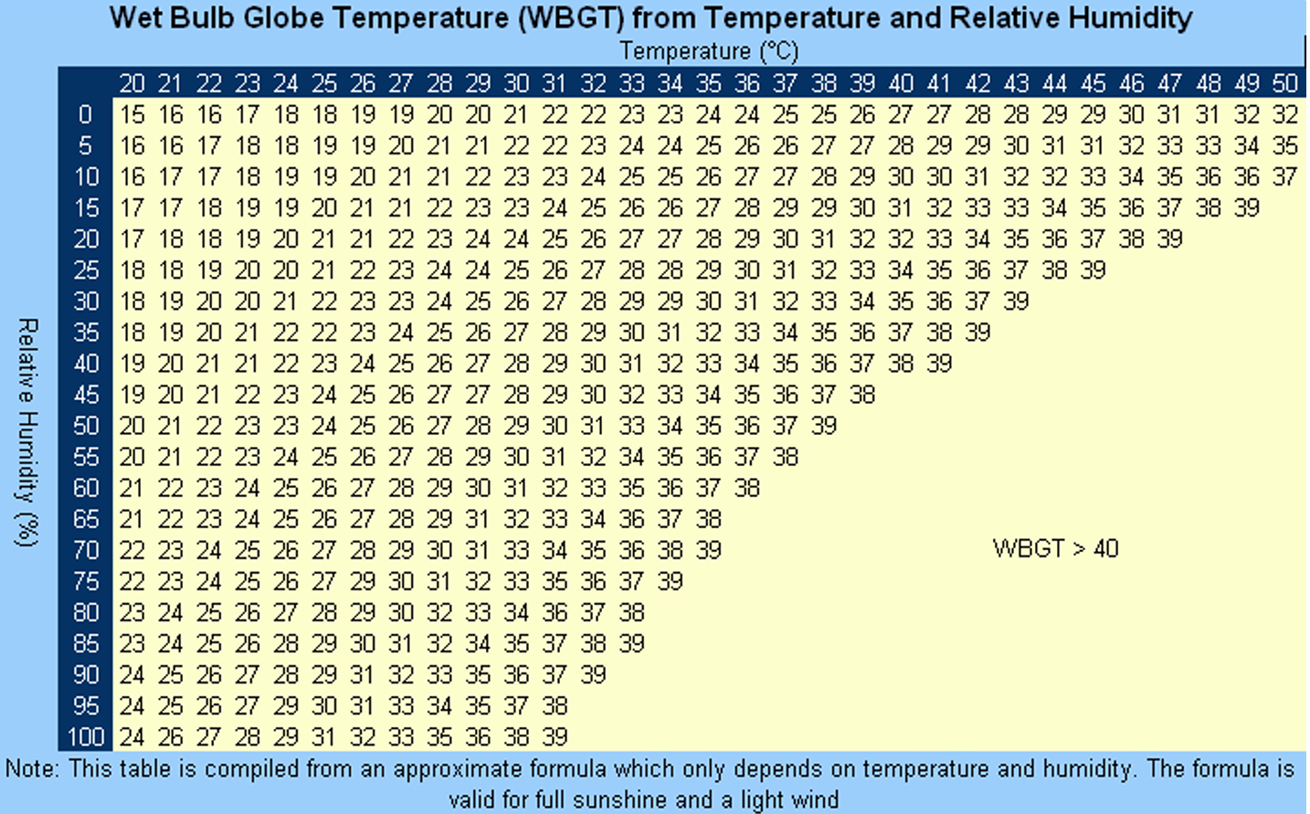
Potential risk mitigations which may be needed if continuing with the event:
If continuing with event, consider what additional mitigations are needed and how these will be communicated to participants where appropriate
- Moving event start times to avoid the hottest times of day
- Shortening courses
- Encouraging switching to a shorter or less physical course (and ensuring sufficient supply of maps to permit this)
- Offering refunds to anyone who feels it would be inappropriate for them to run in the conditions.
- Provision of shade for participants and volunteers
- Provision of water points on the course (over and above the requirement in the BOF rules of orienteering (ref 18.6) for water stations on any event with planned winning time >75 minutes)
- Provision of water points at assembly (not only for drinking but for wetting their own towels / scarfs)
- Carrying of water strongly recommended or made mandatory
- Inclusion of means of rapid cooling in first aid provision (cooling towels, cold water, misting fans…)
- Mandatory whistles / phones / trackers to allow help to be summoned in a timely fashion should a participant be affected by heat related illness (and also reduce risk to event volunteers who might be involved in any search).

