What Should I Do in an Emergency?
- Helping Others
You should give help to anyone in need of assistance for their own safety, abandoning your own course if necessary.

- Checking for Danger
Be aware of hazards that might affect your own safety – don’t become an additional casualty!

- Summoning Help in the Forest

Whistle: | 6 long blasts then a long silence. Repeat until assistance arrives.
Phone: | Phone the emergency number on the map and explain where you are and what has happened. The organisers are the people best placed to get help to you and will coordinate with the emergency services if necessary.  If reception is poor, a text message may go through even if a call won’t connect.  If you have the What3Words App on your mobile phone then it can be used to identify your position exactly:  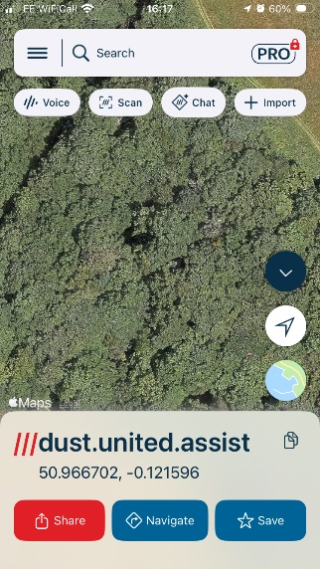  This button identifies your location and gives the What3Words address  This button allows you to share it, e.g. via a text message  If you have the OS Maps App on your mobile phone then it can be used to identify your position using the ‘locate me’ function. This can also be shared via a text message  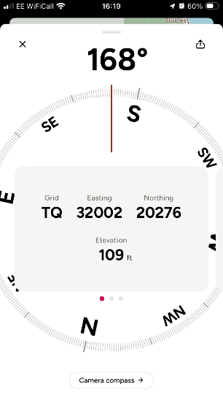  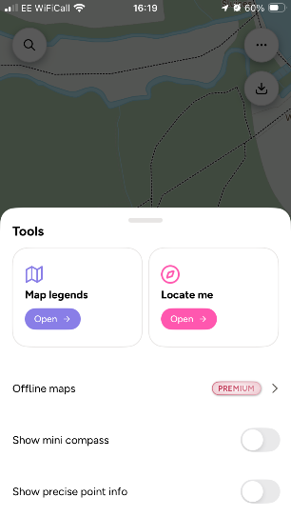  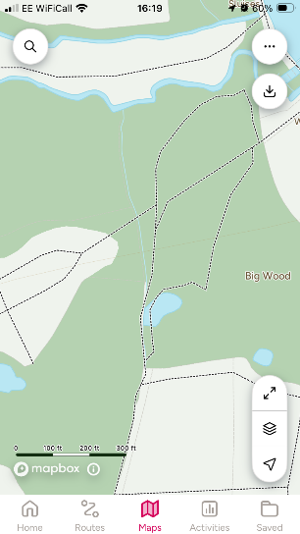

- Providing Assistance

Provide whatever assistance / first aid you are safely able to do.

