
What Should I Do to Stay Safe?
The safety of everyone involved in an orienteering event is the most important aspect of putting it on. The organiser, planner and controller will do their utmost to ensure the safety of all competitors and volunteers but it is important that each person takes some responsibility for their own safety by adhering to the following:
- Before you go to an event read the final event details. If there have been updates, ensure you read them as there may be significant changes due to the weather or land usage. If the organiser has made specific items of clothing, water, whistles etc recommended or mandatory, ensure you know what they are and that you have them with you. If they are mandatory, you MUST carry them with you on the course. Take likely items with you anyway in case they are made mandatory at the last minute or in case conditions when you get there mean you decide to take them with you regardless of what the organiser thinks.

- If you have any medication that you might need at short notice, such as an inhaler, insulin or an epi-pen, ensure you carry it with you when you are on the course. Also ensure that you carry information (on a medical alert bracelet or written on a laminated card) about when you might need the medication, where it is and how it should be administered in case someone else finds you in distress

- Know the map symbols for out of bounds areas and for features that might present specific risks. Here are some of those you are most likely to encounter. A full list of symbols for different map types are available from https://orienteering.sport/iof/mapping/

Out of bounds areas Forbidden Forbidden to  Route: Cross:             |  |  | Compulsory crossing  
Crags / cliffs  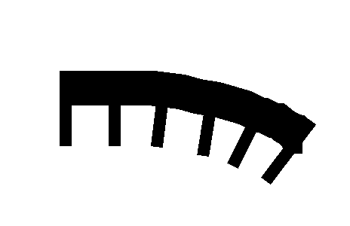 | Water   | Roads   | Uncrossable vegetation  

- Take care at all times not to put yourself at risk but in particular on roads, around water and around other hazards. Do NOT cross any feature marked as uncrossable (black outline or pink line overprinting) including streams, lakes and ponds, fences and walls except at crossing points marked on the map. Do NOT climb down cliffs. Do NOT go into areas marked Out of Bounds.

- If there is a safety briefing, ensure you read it (or listen to it if it is given verbally) and ensure you cooperate fully
  - The safety briefing provides you with information specific to the event including hazards you might encounter during your run.
  - There may also be a written or verbal safety briefing at the start, which may include last minute changes

- Remember the safety bearing information
  - An important part of the safety briefing is the safety bearing information (e.g. “Walk north until you find a wide track then turn west back to the assembly area”). This is vital information for getting you back safely if your map is lost or becomes unreadable

- Make sure to be back by course closing time and download even if you didn’t finish. This allows the organisers to know that you are safely back and avoids sending people out to look for you!

- Run within your capability. If it is hot/cold/foggy/after dark or you have been unwell, change your course to something you can comfortably finish before courses close. If you might be a long time on the course, ensure you start early to give yourself plenty of time

- Be aware of and behave courteously to other users of the area. If there are dogs/mountain bikes/horses or livestock, be extra vigilant and do not approach any animals you do not know

- Go out properly equipped for the activity:
Focused and Ready! (has listened carefully to any information at the start and has thought through the 'safety bearing' information so they would know what to do even if their map blew away)
Sun cream if appropriate
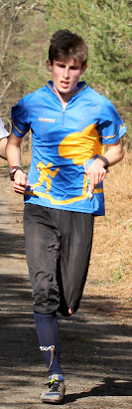
Suitable clothes for the weather (including any items such as cagoules or water bottles which the event organisers have made mandatory)
Full leg and abdomen cover to avoid scratches and ticks. More information about ticks is here
Electronic timing chip or “dibber” on finger (you can hire one of these as you enter an event) - must be downloaded whether you finish or not so the organisers know you have returned safely
Suitable shoes for running in slippery areas
(please clean these between events as we don't want to spread Ash Dieback disease or any other pathogens into the forest)
Neatly folded map - make the first fold parallel to the north lines for ease of lining up the compass.
Map symbols known for 'compulsory crossing', 'out of bounds' and any hazards in the area such as crags, water, roads
Emergency contact number for the event organiser is always printed on the map.

Whistle in pocket (for summoning help in an emergency - 6 long blasts then a long silence. Repeat until rescuers arrive)
Taped laces to avoid tripping
Control description holder on arm (or some juniors find it easier with control descriptions pinned upside down on their shirt)
()
Compass held on map at all times and used to keep map oriented
NOTHING around the neck
Watch (to know when courses close and ensure return before that time)

For night events, there would also be a head torch and a small backup torch.
For urban events, there would be high visibility clothing.
And don't forget any personal equipment such as asthma inhalers that might be needed.

The following comments on mobile phones and GPS trackers are generally true of all events except for elite races at world ranking events:

Competitors are permitted to carry a mobile phone for use in an emergency and we encourage everyone (particularly children and vulnerable adults) to do so. There is an emergency contact number printed on the map (or on the bib at larger events).
Some useful items you might like to add to your mobile phones:
- Set up the ICE number and emergency details if your phone allows this.
- Add the event emergency number.
- Register your mobile phone with the UK 999 text service (it is often possible to get a text message through even when reception is too poor to support a voice call). Text ‘register’ to 999. You will get a reply with instructions to follow. More information is here https://www.emergencysms.net/
- Download the What3Words app to your phone so that you could tell the emergency services your position to within a 3m square. More information is here https://what3words.com/about-us/
- Download the ordnance survey OS Maps app (there is a free version which includes a ‘locate me’ function that gives your current position as a grid reference or latitude/longitude in order to tell the emergency services

Competitors are permitted to engage GPS tracking (via specialist trackers, smart watches or phones) and to share location with others provided it is not accessed for navigation during the race and we encourage everyone (particularly children and vulnerable adults) to do so. If you choose to share location privately with a family member or friend, make sure that the person listed as your emergency contact would know how to access your location.

