Trail Orienteering Development Steering Group Meeting
Virtual Meeting on Zoom, 10 December 2025
- Present
Graham Urquhart (chair) , Liz Urquhart (Team Manager), Christine Roberts YHOA, David Jukes (SCOA, Publicity), Colin Duckworth, Keith Willdig (British Orienteering Board representative), Iain Phillips EMOA , Ian Ditchfield SEOA, Wilbert Hollinger NIOA, John Kewley NWOA, Tom Dobra TVOC, Richard Keighley SWOA
- Chairman's introduction and opening remarks
  - Papers had been circulated prior to the meeting and attached;
Event Update
IOF update
Anne Braggins Trophy proposal
Clive Allens paper on elite coaching
- Conflicts of interest declaration
  - None identified
- Apologies
  - Clive Allen (IOF Liaison), Nick Barrable Co-opted, Charles Bromley Gardner BAOC
- Minutes of previous meeting (12 November 2025) and Matters arising
  - Minutes Approved. Matters arising are covered by the agenda.
For decision:
- GBR TrailO Rules
  - The proposed rules were circulated by Iain Phillips on 1 December. The methodology matching the IOF rules as far as possible, and IP will aim to review and re-aligned a month after the new IOF rules are published for example in 2026. Approved for publication in TrailO site as a baseline as December 2025 rules. GU/KW will approach BO to if any engagement with BO is needed or if we should define the TrailO rules independently, recognising how busy rules committee are with FootO restructure, but proposing that we manage these and keep them informed. IP would support this process. The rules will be applied from the start of 2026.
- Anne Braggins Trophy – proposal circulated by David Jukes on 1 December
  - Proposed as a British award, covering with performance and contribution. Adopted the name ‘The Braggins Award’. Propose to be added to the British Orienteering Awards process (e.g. at the BO AGM). Now looking a finishing, the physical award. GU has asked British Orienteering to track down the box. The box was presented to Anne by the IOF when she retired from the TrailO Commission. We will consider a 2025 award in the first half of next year at the next meeting.
New activities to plan:
- Elite Coaching - paper from Clive Allen attached
  - The proposal is to create one or more people to lead the coaching activities to improve our elite performance and develop new competitors who can become elites on a more formal basis. KW reported that a similar initiative is being pursued by BO for FootO elites and we may be worth tracking or mirror these initiatives. These will provide training activities alongside competition experience. WH suggested that we should add coaching after real events by the course setters and winners to walk through how the solutions were formed. All to consider whether this would be a good initiative, and then who might take the leading roles who will then determine the right activities to support this objective.
- 2026 selection policy
  - This will need to start now, and GU will modify the 2025 policy working with the selectors before the next meeting.
Progress and updates:
- Acquiring TOE – update in covering email
  - Application has been prepared by IP and GU (on behalf of British Orienteering) and sent to the Orienteering Foundation, for a meeting in early February. We will await their response.
- Chair of selectors
  - One of the proposed chair of selectors has been approached and is deciding whether to accept the position.
- Communications
  - This is a quiet period. DJ will continue to publicise new items as they are approved, such as BriTOL, Rules, Selection and the Braggins Award.
- UK Events
  - JK is looking at the possibility of some PreO sprints at JK 2026. We should not commit to this until we a sure that a reasonable event can be mounted, deciding first who will plan/control/organise and can dedicate enough time to these, JK expenses funding, then the source of volunteers, and then consider the planning issues in JK’s paper. JK to discuss with Jon Cross and Keiren March
  - JK is working with Ben Kyd to review locations for TrailO in the North West, and this was circulated (see below).
  - We need a UK fixtures lead to coordinate events in a fixtures group, and this would be a the forum to discuss ideas for events and to formulate a program. All to consider who would like to volunteers from this group or outside to form a fixtures committee to manage these ideas and propose the program to the Steering Group.
- IOF
  - Paper was circulated.
- Any other business
  - GU had not circulated the final BriTOL rules and so this was done at the meeting. If there are no further comments on the minor amendments by 14th December 2025 the BriTOL rules will are approved. TD will then complete the technical set up for BriTOL 2026 in TOP.
- Action updates
  - Completed actions were removed from the list
- Date and focus of next meeting
  - The next meeting will be in early February (GU to arrange), to give us an opportunity to review a response from the Orienteering Foundation regarding TOE, Selection and UK events. [Update – given timing of the OF likely response and other developments this will be late February 26]
Actions from previous meeting and action list
Ref. | Item | Action | Who | Update
 |  | GU to review the representative membership of the Steering Group with Keith and the Board to make sure it remains fit for purpose. | GU | End 2025
 |  | TD will complete the technical set up for BriTOL 2026 on TOP. | TD | Feb 2026
 |  | All to consider who would like to volunteers from this group or outside to form a fixtures committee to manage these ideas and propose the program to the Steering Group. | All | Next meeting
 |  | All to consider whether the elite coaching group would be a good initiative, and then who might take the leading roles who will then determine the right activities to support this objective. | All | Next meeting
 |  | GU/KW will approach BO to if any engagement with BO is needed or if we should define the TrailO rules independently | GU/KW
 |  | GU to work with the selectors to create the 2026 selection policy. | GU | Next meeting

Papers circulated before meeting:
Annex C – The Braggins Award
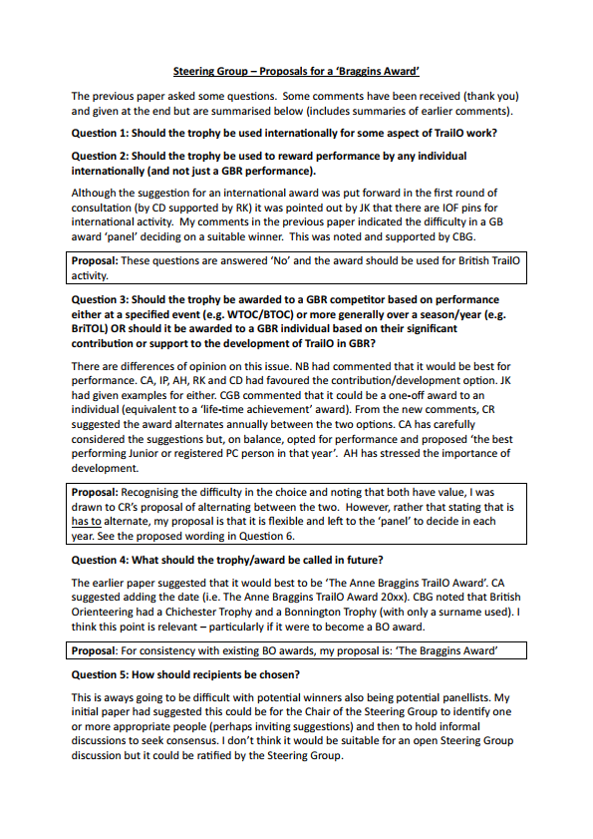

TrailO at Elite Level – an idea for consideration (Clive Allen)
At WTOC this year, almost everyone in the team demonstrated their top level of performance at some point or other, but failed to do so consistently across the whole competition.
The numbers from GBR attending ECTO and WRE events are very encouraging, and this is the best means of gaining more high-level competition experience and improving personal standards. But I think GB TrailO teams might gain further in achievement levels and consistency if everyone had more opportunity to learn from each other, through some formalised discussion and training.
Having a formalized training structure, with an appointed leader, would also add to the status of our discipline within British Orienteering. It should also enable a greater number of active trail orienteers (competing regularly at events in the UK, and often also in TORUS competitions) to become more 'involved'. Involvement could be recognized through being on a regular elite training e-mail list and/or social media group. Special attention could be given to getting as many juniors, P-class athletes and younger adults as possible into this group.
So I'd like to raise the suggestion of introducing a 'training coordinator’ concept; a person who would arrange formal discussion (online) of the courses and outcomes at international events (ECTO/WRE/championships) immediately afterwards, that anyone could attend. The online meetings would in effect be a formalisation of the post-event online discussions that have often been arranged by John Kewley.
An annual programme might include having a special training day once per year, open to anyone with 2-3 events behind them and maybe aimed especially at juniors, preferably with a competition the previous or following day. It could be good to have input from a trailO coach from abroad on such an occasion.
I see the training coordinator as not required to have any special qualifications, although some knowledge of coaching methods and techniques would obviously be useful. It should be someone who knows at least ECTO level through personal experience. To me, the main qualification would be a strong belief in the merits of such a project, and the energy and initiative to provide as many inclusive activities as possible for members of this elite training group, and finding suitably qualified activity leaders to help where needed.
Clive Allen, November 2025

v.3 GU 24/02/26

