

British Orienteering
Chair
Application Form
2018

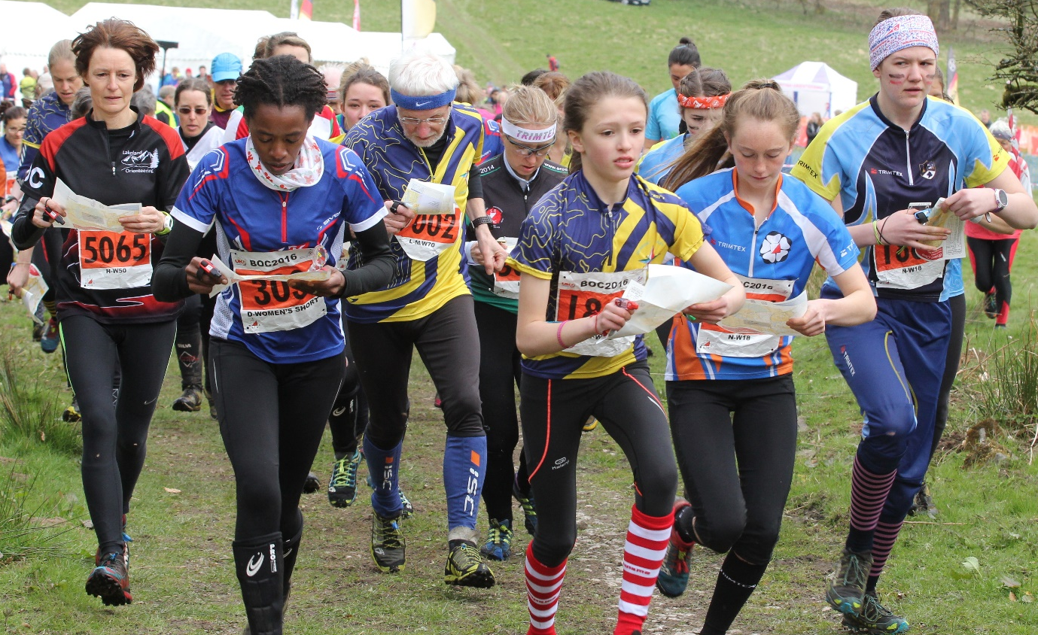
Photo Rob Lines

Application Form

Personal Details:
Title: |  | Surname:
Forename(s):
Address:
County: |  |  |  |  |  |  | Post Code:
Email Address:
Day Tel: |  |  |  |  | Eve Tel:
Mobile:
Do you have a driving licence? |  |  |  |  |  | Do you have daytime access to a car?
Preferred method of contact:
Post: Email: Day Tel: Eve Tel: Mobile:

Qualifications and Training
Please list all relevant qualifications, training courses attended and awards gained relevant for this post.

Current Employment Details
Name & Address
Job Title
Brief job description

Reasons for your application
Please state why this post is of interest to you.

Please explain how your skills, experience and aptitudes make you suitable for this position. You may continue on a separate sheet if necessary.
Skills & Aptitudes | Experience
Accountability
Communication
Financial Awareness
Governance
Influencing
Relationship building
Strategic thinking
Vision setting

Please give the details of two referees whom we can approach for a reference, please note that we will not accept family members or partners as referees.

Referee 1
Name:
Organisation:
Address:
County: |  |  | Post Code:
Position within Organisation:
Email:
Tel: |  |  | Mobile:

Referee 2
Name:
Organisation:
Address:
County: |  |  | Post Code:
Position within Organisation:
Email:
Tel: |  |  | Mobile:

Gender: | Male: Female:
Ethnicity: please tick the group with which you most closely identify:
African: Bangladeshi: Black (Caribbean): Black (UK):
Chinese: Indian: Pakistani: White (UK):
Other:
Disability or impairment: please specify any impairment, disability or other special requirement:

Deadline for applications is Friday 9 November 2018

Interviews: Week commencing 3 December 2018

Declaration

Please note: Providing any misleading or false information will disqualify you from appointment. If appointed, it will render you liable to dismissal without notice.
I have read the above statement. By submission of this application I declare that the information given by me on this form now, and subsequently provided by me in connection with this application for employment, is complete and correct to the best of my knowledge. All questions relating to me have been correctly and fully answered. I possess the qualification(s) which I claim to hold. I also understand and accept that verification may be sought as to the factual basis of the information I have provided.

Signed |  |  | Date

Please ensure you fill out the GDPR Recruitment and Selection statement below and return to our HR department with your application.
We will be unable to process application forms without the GDPR Statement signed, and your application will be destroyed.

General Data Protection Regulations 2018 – Recruitment & Selection
Privacy Statement
British Orienteering takes your privacy seriously and will only use your personal information to administer your application for employment. This privacy statement explains what personal data we collect from you and how we use it. We encourage you to read the summaries below and if you would like more information on a particular topic please contact our Data Protection Officer by writing to British Orienteering, Scholes Mill, Old Coach Road, Tansley, Matlock DE4 5FY 01629 583037.
Personal Data We Collect
We collect the following personal data relating to your employment application:
- Contact Details (Name, Address, Email Address, Telephone &/or Mobile Number)
- Employment history
- Qualifications

How We Use Personal Data
Your personal data will be used to process your application.

How Long We Will Hold Personal Data
Successful candidate’s data will be held under the company’s General Data Protection Policy details of which will be made available upon the offer of employment.
Unsuccessful candidate’s data will be held of a period of 6 months where upon it will be confidentially destroyed.

Reasons We Share Personal Data
We will not normally share personal data with anyone else, but may do so where:
- There is an issue that puts the safety of our staff at risk
- We need to liaise with other agencies or third parties – we will seek consent as necessary before doing this

We will also share personal data with law enforcement and government bodies where we are legally required to do so, including for:
- The prevention or detection of crime and/or fraud
- The apprehension or prosecution of offenders
In connection with legal proceedings
- Where the disclosure is required to satisfy our legal obligations

How We Protect Your Personal Data
We use encrypted storage and transfer for all electronic data and have password access controls in place. If paper copies are utilised, we ensure that all information is held in secure locked cabinets with controlled access by named individuals.

How to Access & Control Your Personal Data
Individuals have a right to make a ‘subject access request’ to gain access to personal information that the company holds about them. This includes:
- Confirmation that their personal data is being processed
- Access to a copy of the data
- The purposes of the data processing
- The categories of personal data concerned
- Who the data has been, or will be, shared with
- How long the data will be stored for, or if this isn’t possible, the criteria used to determine this period
- The source of the data, if not the individual
- Whether any automated decision-making is being applied to their data, and what the significance and consequences of this might be for the individual

Subject access requests must be submitted in writing, either by letter or email to the DPO.
They should include:
- Name of individual
- Correspondence address
- Contact number and email address
- Details of the information requested

When responding to requests, we:
- May ask the individual to provide 2 forms of identification
- May contact the individual via phone to confirm the request was made
- Will respond without delay and within 1 month of receipt of the request
- Will provide the information free of charge
- May tell the individual we will comply within 3 months of receipt of the request, where a request is complex or numerous. We will inform the individual of this within 1 month, and explain why the extension is necessary
- If the request is unfounded or excessive, we may refuse to act on it, or charge a reasonable fee which takes into account administrative costs. A request will be deemed to be unfounded or excessive if it is repetitive or asks for further copies of the same information. When we refuse a request, we will tell the individual why, and tell them they have the right to complain to the ICO.

Other data protection rights of the individual: In addition to the right to make a subject access request (see above), and to receive information when we are collecting their data about how we use and process it, individuals also have the right to:
- Withdraw their consent to processing at any time
- Ask us to rectify, erase or restrict processing of their personal data, or object to the processing of it (in certain circumstances)
- Prevent use of their personal data for direct marketing
- Challenge processing which has been justified based on public interest
- Request a copy of agreements under which their personal data is transferred outside of the European Economic Area
- Object to decisions based solely on automated decision making or profiling (decisions taken with no human involvement, that might negatively affect them)
- Prevent processing that is likely to cause damage or distress
- Be notified of a data breach in certain circumstances
- Make a complaint to the ICO
- Ask for their personal data to be transferred to a third party in a structured, commonly used and machine-readable format (in certain circumstances)

NOTE: Individuals should submit any request to exercise these rights to the DPO. If staff receive such a request, they must immediately forward it to the DPO.

Consent
I have read and consent to my personal data, as detail above, being held and utilised by British Orienteering for the purposes stated.

Signed: ………………………………………………………………. Date: ………………………………….

Please send a copy of your signed GDPR Form to info@britishorienteering.org.uk or by mail marked “Confidential” to the HR Department, British Orienteering, Scholes Mill, Old Coach Road, Tansley, Matlock DE4 5FY

